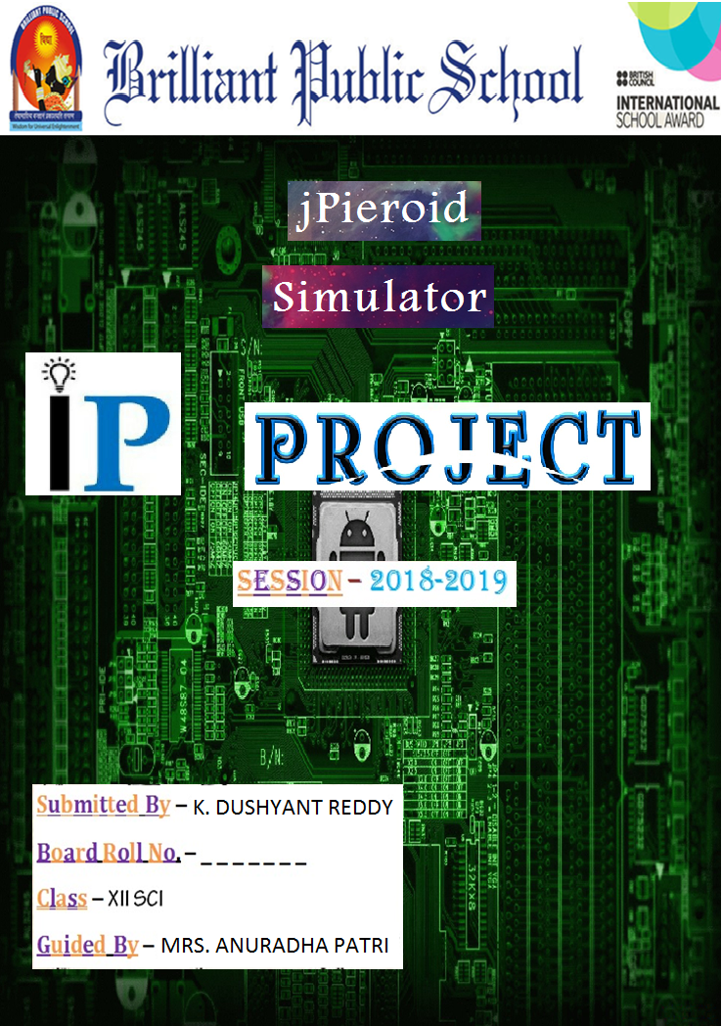

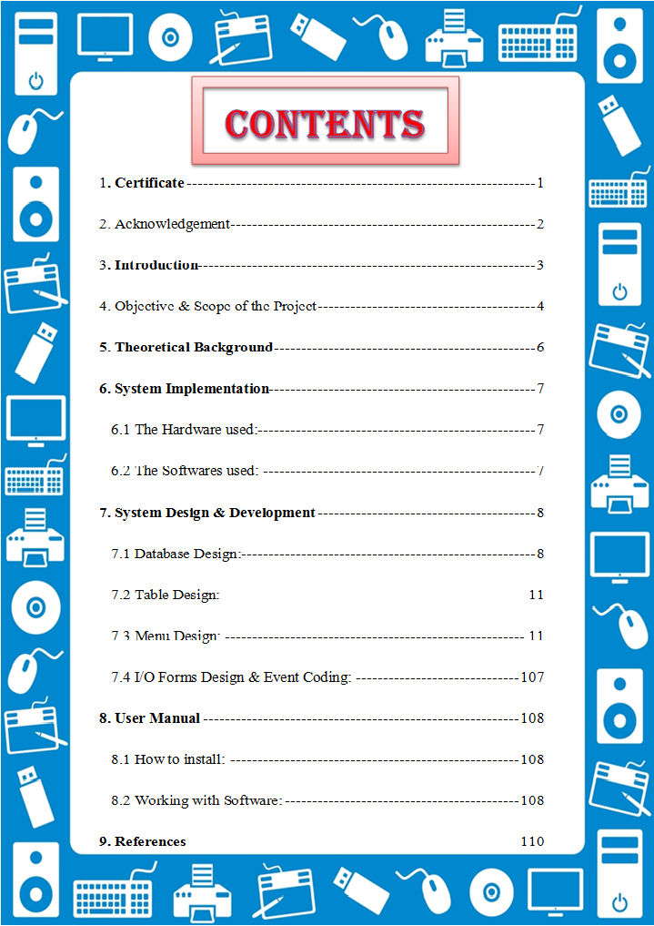



In the accomplishment of this project successfully, many people have supported and guided me and I am utilizing this time to thank all of them. I wish to express my deep gratitude and sincere thanks to the Principal, **MRS. SHRUTI GUPTA** mam, Brilliant Public School for her encouragement and for all the facilities that she provided. I extend my hearty thanks to **MRS. ANURADHA PATRI** mam, IP teacher, who guided me to the successful completion of this project. I take this opportunity to express my deep sense of gratitude for her invaluable guidance, constant encouragement, which has sustained my efforts at all the stages of this project work…

I would like to thank **UNNATI** mam and **SIMRANJEET** sir who have solved the problems which I had faced. I can’t forget to offer my sincere thanks to parents who helped me for their valuable advice and support, which I received from them time to time….

**3. Introduction**

This software project is developed to automate the functionalities of an Android. The purpose of the software project is to develop the Management Information System (MIS) to automate the record keeping of Contacts, Calculator, Game and Restaurant issue and receive transactions with a view to enhance the decision making of the functionaries.

A MIS mainly consists of a computerized database, a collection of inter-related tables for a particular subject or purpose, capable to produce different reports relevant to the user. An application program is tied with the database for easy access and interface to the database. Using Application program or front-end, we can store, retrieve and manage all information in proper way.

This software, being simple in design and working, does not require much of training to users, and can be used as a powerful tool for automating an Android interface.

During coding and design of the software Project, Java NetBeans IDE, a powerful front-end tool is used for getting Graphical User Interface (GUI) based integrated platform and coding simplicity. As a back-end a powerful, open source RDBMS, MySQL is used as per requirement of the CBSE curriculum of Informatics Practices Course.

**4. objective & scope of project**

The objective of the software project is to develop a computerized MIS to automate the functions of an jPieroid. This software project is also aimed to enhance the current record keeping system, which will help managers to retrieve the up-to-date information at right time in right shape.

The proposed software system is expected to do the following functionality-

* To provide a user friendly and Graphical User Interface (GUI).
* The proposed system should maintain all the records and transactions, and should generate the required reports and information when required.
* To provide graphical and user-friendly interface to interact with a centralized database based on client-server architecture.
* To identify the critical operation procedure and possibilities of simplification using modern IT tools and practices.

In its current scope, the software enables user to retrieve and update the information from centralized database designed with MySQL . This software does not require much training time of the users due to limited functionality and simplicity.

During the development of jPieroid project, Java NetBeans IDE, a powerful, open source event-driven form-based development environment is used for modular design and future expandability of the system.

Despite of the best effort of the developer, the following limitations and functional boundaries are visible, which limits the scope of this application software.

1. This software can store records and produce reports in pre-designed format in soft copy. There is no facility yet to produce customized reports. Only specified reports are covered.
2. There is no provision to calculate fine or penalty etc. for defaulter members; however it can be

developed easily with the help of adding modules.

**5. Theoretical background**

5.1 What islogo-mysql?

The management of data in a database system is done by means of a general-purpose software package called a Database Management System (DBMS). Some commercially available RDBMS are MS SQL Server, MS ACCESS, INGRES, ORACLE, and Sybase. MySQL, the most popular Open Source SQL database management system, is developed, distributed, and supported by Oracle Corporation. MySQL is named after co-founder Monty Widenius's daughter, My. The name of the MySQL Dolphin (our logo) is “Sakila,”.

* **MySQL is a database management system.**

A database is a structured collection of data. It may be anything from a simple shopping list to a picture gallery or the vast amounts of information in a corporate network. To add, access, and process data stored in a computer database, you need a database management system such as MySQL Server. Since computers are very good at handling large amounts of data, database management systems play a central role in computing, as standalone utilities, or as parts of other applications.

* **MySQL is based on SQL.**

A relational database stores data in separate tables rather than putting all the data in one big storeroom. This adds speed and flexibility. The SQL part of “MySQL” stands for “Structured Query Language.” SQL is the most common standardized language used to access databases and is defined by the ANSI/ISO SQL Standard. The SQL standard has been evolving since 1986 and several versions exist. In this manual, “SQL-92” refers to the standard released in 1992, “SQL:1999” refers to the standard released in 1999, and “SQL:2003” refers to the current version of the standard.

* **The MySQL Database Server is very fast, reliable, and easy to use.**

MySQL Server was originally developed to handle large databases much faster than existing solutions and has been successfully used in highly demanding production environments for several years. Although under constant development, MySQL Server today offers a rich and useful set of functions. Its connectivity, speed, and security make MySQL Server highly suited for accessing databases on the Internet.

* **MySQL Server works in client/server or embedded systems.**

The MySQL Database Software is a client/server system that consists of a multi-threaded SQL server that supports different backends, several different client programs and libraries, administrative tools, and a wide range of application programming interfaces (APIs).

## 5.2 What is 1_iIXOmGDzrtTJmdwbn7cGMw?

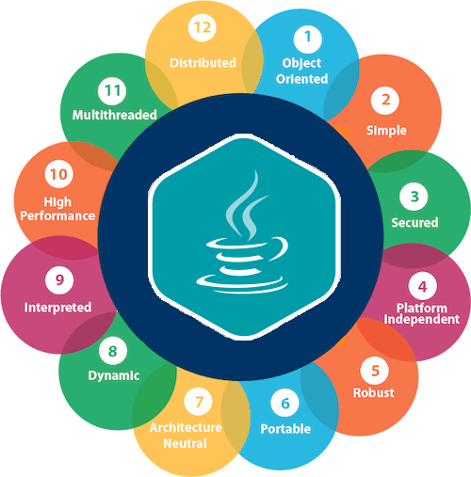NetBeans started as a student project (originally called Xelfi) in the Czech Republic in 1996. The goal was to write a Delphi-like Java IDE in Java. Xelfi was the first Java IDE (Integrated Development Environment) written in Java, with its first pre-releases in 1997. Xelfi was a fun project to work on, especially since Java IDE space was uncharted territory at that time. The project attracted enough interest that these students, once they graduated, decided that they could market it as a commercial product. Soliciting resources from friends and relatives for a web space, they formed a company around it.

Soon after, they were contacted by [Roman Stanek](http://www.google.com/search?q=roman+stanek&hl=en&lr=&c2coff=1&client=safari&rls=en&start=10&sa=N), an entrepreneur who had already been involved in several startups in the Czech Republic. He was looking for a good idea to invest in, and discovered Xelfi. He met with the founders; they hit it off, and a business was born.

In the spring of 1999, [NetBeans DeveloperX2](http://www.internetnews.com/dev-news/article.php/75561) was released, supporting Swing. The performance improvements that came in JDK 1.3, released in the fall of 1999, made NetBeans a viable choice for development tools. By the summer of 1999, the team was hard at work re-*architecting* DeveloperX2 into the more modular NetBeans that forms the basis of the software today.

Something else was afoot in the summer of 1999: [Sun Microsystems](http://www.sun.com) wanted better Java development tools, and had become interested in NetBeans. It was a dream come true for the NetBeans team: NetBeans would become the flagship tool set of the maker of Java itself! By the Fall, with the next generation of NetBeans Developer in beta, a deal was struck. Sun Microsystems had also acquired another tools company, During the acqusition, the young developers who had been involved in open-source projects for most of their programming careers, mentioned the idea of open-sourcing NetBeans. Fast forward to less than six months later, the decision was made that NetBeans would be open sourced. While Sun had contributed considerable amounts of code to open source projects over the years, this was Sun's first *sponsored* open source project, one in which Sun would be paying for the site and handling the infrastructure.

**6. System implementation**

*6.1 The Hardware used:*

## 

## While developing the system, the hardware used are:

PC with Intel® Core™2 Duo processor having 4 GB RAM or sometimes, PC with Pentium processor having 2 GB RAM, SVGA and other required devices.

## 

## 6.2 The Software used:

## While developing the system, the software used are:

* Microsoft Windows® 7 as Operating System.
* Java NetBeans 8.2 as Front-end Development environment.
* MySQL as Back-end Server with Database for Testing.
* MS-Word 2010 for documentation.

**5. System design & development**

5.i. Database Design:

A database is a container object which contains tables, queries, reports and data validation policies enforcement rules or constraints etc. A logical data often represented as a records are kept in different tables after reducing anomalies and redundancies. The goodness of data base design lies in the table structure and its relationship.

Database: jos

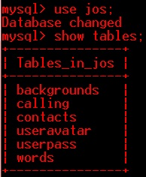

### 5.ii. Table Design:

The database of jPieroid Simulator contains 6 tables. The tables are normalized to minimize the redundancies of data and enforcing the validation rules of the organization. Most of the tables are designed to store master records. The tables and their structure are given below.

Table: backgrounds

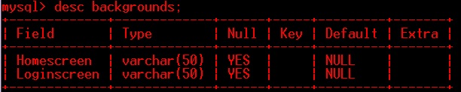

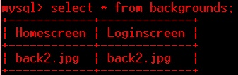

Table: calling

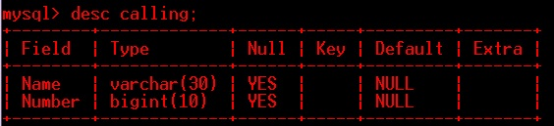

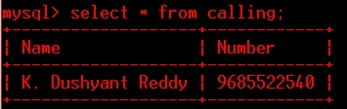

Table: contacts

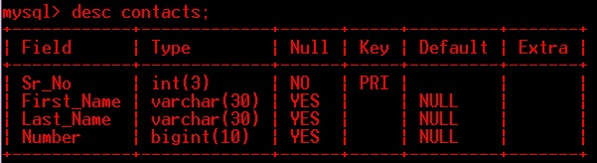

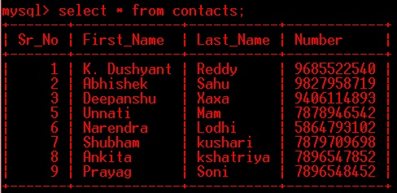

Table: useravatar

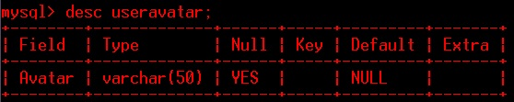

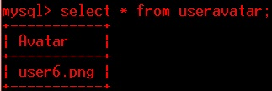

Table: userpass

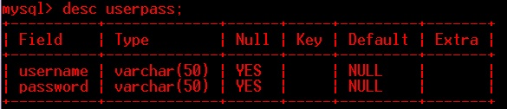

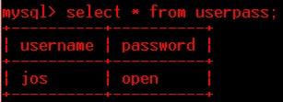

Table: words

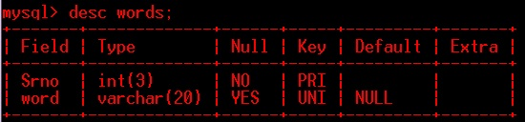

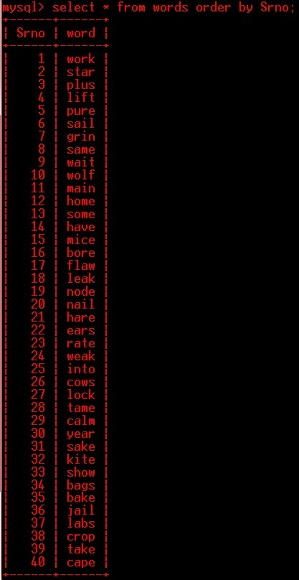

### 5.iii. menu Design:

### 1.Home menu

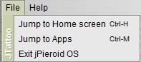 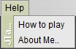

### 5.iv. I/o forms Design and event coding:

The software project for jPieroid Simulator contains various forms along with programming codes. Forms (JFrames) and their event coding are given below.

i. **Commands used to import different libraries**

import javax.swing.JOptionPane;

import java.math.BigInteger;

import javax.swing.table.DefaultTableModel;

import javax.swing.ImageIcon;

import java.sql.ResultSet;

import java.sql.DriverManager;

import java.sql.Connection;

import java.sql.Statement;

import javax.swing.UIManager;

import javax.swing.UIManager.LookAndFeelInfo;

import javax.swing.UnsupportedLookAndFeelException;

**public class Login extends javax.swing.JFrame** {

String curusername;

String curpassword;

private double firstnum = 0.0;

private double secondnum = 0.0;

private double result = 0.0;

String operations;

private int wordcount = 1;

private int trycount = 1;

private int delsrno = 0;

public Login() {

initComponents();

//JDBC part getting username and password------------------------------//

try {

Class.forName("java.sql.Driver");

Connection con = DriverManager.getConnection("jdbc:mysql://localhost:3306/jos", "root", "bps");

Statement stmt = con.createStatement();

String query = "Select \* from userpass";

ResultSet rs = stmt.executeQuery(query);

if (rs.first()) {

curusername = rs.getString(1);

curpassword = rs.getString(2);

}

} catch (Exception e) {

System.out.println("Error");

}

//---------------------------------------------------------------------//

//JDBC part setting wallpaper------------------------------------------//

try {

Class.forName("java.sql.Driver");

Connection con = DriverManager.getConnection("jdbc:mysql://localhost:3306/jos", "root", "bps");

Statement stmt = con.createStatement();

String query = "Select \* from backgrounds";

ResultSet rs = stmt.executeQuery(query);

if (rs.first()) {

String homebackg = rs.getString(1);

String loginbackg = rs.getString(2);

homelabel.setIcon(new ImageIcon(getClass().getResource(homebackg)));

menulabel.setIcon(new ImageIcon(getClass().getResource(homebackg)));

loginlabel.setIcon(new ImageIcon(getClass().getResource(loginbackg)));

}

} catch (Exception e) {

System.out.println("Error");

}

//---------------------------------------------------------------------//

//JDBC part useravatar-------------------------------------------------//

try {

Class.forName("java.sql.Driver");

Connection con = DriverManager.getConnection("jdbc:mysql://localhost:3306/jos", "root", "bps");

Statement stmt = con.createStatement();

String query = "Select \* from useravatar";

ResultSet rs = stmt.executeQuery(query);

if (rs.first()) {

String avatar = rs.getString(1);

userlabel.setIcon(new ImageIcon(getClass().getResource(avatar)));

}

} catch (Exception e) {

System.out.println("Error");

}

//---Contacts display in table--//

addcontact.setVisible(false);

updatepanel.setVisible(false);

contactpanel.setVisible(true);

try {

DefaultTableModel tb = (DefaultTableModel) cnttb.getModel();

Class.forName("java.sql.Driver");

Connection con = DriverManager.getConnection("jdbc:mysql://localhost:3306/jos", "root", "bps");

Statement stmt = con.createStatement();

String query = "Select \* from contacts";

ResultSet rs = stmt.executeQuery(query);

while (rs.next()) {

int srno = rs.getInt(1);

String fname = rs.getString(2);

String lname = rs.getString(3);

BigInteger num = new BigInteger(rs.getString(4));

tb.addRow(new Object[]{srno, fname, lname, num});

}

con.close();

stmt.close();

rs.close();

} catch (Exception e) {

}

//-----name display in recent called-//

try {

Class.forName("java.sql.Driver");

Connection con = DriverManager.getConnection("jdbc:mysql://localhost:3306/jos", "root", "bps");

Statement stmt = con.createStatement();

String query = "Select \* from calling";

ResultSet rs = stmt.executeQuery(query);

String name = "", num = "";

while (rs.next()) {

name = rs.getString(1);

num = rs.getString(2);

}

pbname1.setText(name);

pbnum1.setText("" + num);

con.close();

stmt.close();

rs.close();

} catch (Exception e) {

System.out.println("Error in connectivity");

}

//-----button properties---//

cbbutn.setOpaque(false);

cbbutn.setContentAreaFilled(false);

cbbutn.setBorderPainted(false);

cnttb.setOpaque(false);

contactpanel.getViewport().setOpaque(false);

cnttb.setBackground(null);

contactpanel.setBackground(null);

//---------------------------------------------------------------------//

//setting buttons transparent

subbutton1.setOpaque(false);

subbutton1.setContentAreaFilled(false);

subbutton1.setBorderPainted(false);

homebutton.setOpaque(false);

homebutton.setContentAreaFilled(false);

homebutton.setBorderPainted(false);

powbutton.setOpaque(false);

powbutton.setContentAreaFilled(false);

powbutton.setBorderPainted(false);

backbutton.setOpaque(false);

backbutton.setContentAreaFilled(false);

backbutton.setBorderPainted(false);

cancelbutton1.setOpaque(false);

cancelbutton1.setContentAreaFilled(false);

cancelbutton1.setBorderPainted(false);

appbutton.setOpaque(false);

appbutton.setContentAreaFilled(false);

appbutton.setBorderPainted(false);

calcbutton.setOpaque(false);

calcbutton.setContentAreaFilled(false);

calcbutton.setBorderPainted(false);

billbutton.setOpaque(false);

billbutton.setContentAreaFilled(false);

billbutton.setBorderPainted(false);

aboutbutton.setOpaque(false);

aboutbutton.setContentAreaFilled(false);

aboutbutton.setBorderPainted(false);

npbutton.setOpaque(false);

npbutton.setContentAreaFilled(false);

npbutton.setBorderPainted(false);

gamebutton.setOpaque(false);

gamebutton.setContentAreaFilled(false);

gamebutton.setBorderPainted(false);

settingbutton.setOpaque(false);

settingbutton.setContentAreaFilled(false);

settingbutton.setBorderPainted(false);

calcbutton1.setOpaque(false);

calcbutton1.setContentAreaFilled(false);

calcbutton1.setBorderPainted(false);

billbutton1.setOpaque(false);

billbutton1.setContentAreaFilled(false);

billbutton1.setBorderPainted(false);

gamebutton1.setOpaque(false);

gamebutton1.setContentAreaFilled(false);

gamebutton1.setBorderPainted(false);

contactbutton1.setOpaque(false);

contactbutton1.setContentAreaFilled(false);

contactbutton1.setBorderPainted(false);

homebutton1.setOpaque(false);

homebutton1.setContentAreaFilled(false);

homebutton1.setBorderPainted(false);

powbutton1.setOpaque(false);

powbutton1.setContentAreaFilled(false);

powbutton1.setBorderPainted(false);

backbutton1.setOpaque(false);

backbutton1.setContentAreaFilled(false);

backbutton1.setBorderPainted(false);

homebutton3.setOpaque(false);

homebutton3.setContentAreaFilled(false);

homebutton3.setBorderPainted(false);

powbutton3.setOpaque(false);

powbutton3.setContentAreaFilled(false);

powbutton3.setBorderPainted(false);

backbutton3.setOpaque(false);

backbutton3.setContentAreaFilled(false);

backbutton3.setBorderPainted(false);

homebutton4.setOpaque(false);

homebutton4.setContentAreaFilled(false);

homebutton4.setBorderPainted(false);

powbutton4.setOpaque(false);

powbutton4.setContentAreaFilled(false);

powbutton4.setBorderPainted(false);

backbutton4.setOpaque(false);

backbutton4.setContentAreaFilled(false);

backbutton4.setBorderPainted(false);

homebutton5.setOpaque(false);

homebutton5.setContentAreaFilled(false);

homebutton5.setBorderPainted(false);

backbutton5.setOpaque(false);

backbutton5.setContentAreaFilled(false);

backbutton5.setBorderPainted(false);

powbutton5.setOpaque(false);

powbutton5.setContentAreaFilled(false);

powbutton5.setBorderPainted(false);

backbutton6.setOpaque(false);

backbutton6.setContentAreaFilled(false);

backbutton6.setBorderPainted(false);

homebutton6.setOpaque(false);

homebutton6.setContentAreaFilled(false);

homebutton6.setBorderPainted(false);

powbutton6.setOpaque(false);

powbutton6.setContentAreaFilled(false);

powbutton6.setBorderPainted(false);

backbutton7.setOpaque(false);

backbutton7.setContentAreaFilled(false);

backbutton7.setBorderPainted(false);

homebutton7.setOpaque(false);

homebutton7.setContentAreaFilled(false);

homebutton7.setBorderPainted(false);

displaybut.setOpaque(false);

displaybut.setContentAreaFilled(false);

displaybut.setBorderPainted(false);

powbutton7.setOpaque(false);

powbutton7.setContentAreaFilled(false);

powbutton7.setBorderPainted(false);

backbutton8.setOpaque(false);

backbutton8.setContentAreaFilled(false);

backbutton8.setBorderPainted(false);

homebutton8.setOpaque(false);

homebutton8.setContentAreaFilled(false);

homebutton8.setBorderPainted(false);

userbut.setOpaque(false);

userbut.setContentAreaFilled(false);

userbut.setBorderPainted(false);

passchangebut.setOpaque(false);

passchangebut.setContentAreaFilled(false);

passchangebut.setBorderPainted(false);

powbutton8.setOpaque(false);

powbutton8.setContentAreaFilled(false);

powbutton8.setBorderPainted(false);

backbutton9.setOpaque(false);

backbutton9.setContentAreaFilled(false);

backbutton9.setBorderPainted(false);

homebutton9.setOpaque(false);

homebutton9.setContentAreaFilled(false);

homebutton9.setBorderPainted(false);

wallbut1.setOpaque(false);

wallbut1.setContentAreaFilled(false);

wallbut1.setBorderPainted(false);

wallbut2.setOpaque(false);

wallbut2.setContentAreaFilled(false);

wallbut2.setBorderPainted(false);

wallbut3.setOpaque(false);

wallbut3.setContentAreaFilled(false);

wallbut3.setBorderPainted(false);

wallbut4.setOpaque(false);

wallbut4.setContentAreaFilled(false);

wallbut4.setBorderPainted(false);

wallbut5.setOpaque(false);

wallbut5.setContentAreaFilled(false);

wallbut5.setBorderPainted(false);

wallbut6.setOpaque(false);

wallbut6.setContentAreaFilled(false);

wallbut6.setBorderPainted(false);

wallbut7.setOpaque(false);

wallbut7.setContentAreaFilled(false);

wallbut7.setBorderPainted(false);

wallbut8.setOpaque(false);

wallbut8.setContentAreaFilled(false);

wallbut8.setBorderPainted(false);

wallbut9.setOpaque(false);

wallbut9.setContentAreaFilled(false);

wallbut9.setBorderPainted(false);

wallbut10.setOpaque(false);

wallbut10.setContentAreaFilled(false);

wallbut10.setBorderPainted(false);

wallbut11.setOpaque(false);

wallbut11.setContentAreaFilled(false);

wallbut11.setBorderPainted(false);

wallbut12.setOpaque(false);

wallbut12.setContentAreaFilled(false);

wallbut12.setBorderPainted(false);

wallbut13.setOpaque(false);

wallbut13.setContentAreaFilled(false);

wallbut13.setBorderPainted(false);

wallbut14.setOpaque(false);

wallbut14.setContentAreaFilled(false);

wallbut14.setBorderPainted(false);

userbut1.setOpaque(false);

userbut1.setContentAreaFilled(false);

userbut1.setBorderPainted(false);

userbut2.setOpaque(false);

userbut2.setContentAreaFilled(false);

userbut2.setBorderPainted(false);

userbut3.setOpaque(false);

userbut3.setContentAreaFilled(false);

userbut3.setBorderPainted(false);

userbut4.setOpaque(false);

userbut4.setContentAreaFilled(false);

userbut4.setBorderPainted(false);

userbut5.setOpaque(false);

userbut5.setContentAreaFilled(false);

userbut5.setBorderPainted(false);

userbut6.setOpaque(false);

userbut6.setContentAreaFilled(false);

userbut6.setBorderPainted(false);

userbut7.setOpaque(false);

userbut7.setContentAreaFilled(false);

userbut7.setBorderPainted(false);

userbut8.setOpaque(false);

userbut8.setContentAreaFilled(false);

userbut8.setBorderPainted(false);

userbut9.setOpaque(false);

userbut9.setContentAreaFilled(false);

userbut9.setBorderPainted(false);

userbut10.setOpaque(false);

userbut10.setContentAreaFilled(false);

userbut10.setBorderPainted(false);

userbut11.setOpaque(false);

userbut11.setContentAreaFilled(false);

userbut11.setBorderPainted(false);

userbut12.setOpaque(false);

userbut12.setContentAreaFilled(false);

userbut12.setBorderPainted(false);

userbut13.setOpaque(false);

userbut13.setContentAreaFilled(false);

userbut13.setBorderPainted(false);

userbut14.setOpaque(false);

userbut14.setContentAreaFilled(false);

userbut14.setBorderPainted(false);

userbut15.setOpaque(false);

userbut15.setContentAreaFilled(false);

userbut15.setBorderPainted(false);

powbutton9.setOpaque(false);

powbutton9.setContentAreaFilled(false);

powbutton9.setBorderPainted(false);

backbutton10.setOpaque(false);

backbutton10.setContentAreaFilled(false);

backbutton10.setBorderPainted(false);

homebutton10.setOpaque(false);

homebutton10.setContentAreaFilled(false);

homebutton10.setBorderPainted(false);

powbutton10.setOpaque(false);

powbutton10.setContentAreaFilled(false);

powbutton10.setBorderPainted(false);

backbutton11.setOpaque(false);

backbutton11.setContentAreaFilled(false);

backbutton11.setBorderPainted(false);

homebutton11.setOpaque(false);

homebutton11.setContentAreaFilled(false);

homebutton11.setBorderPainted(false);

contactbutton.setOpaque(false);

contactbutton.setContentAreaFilled(false);

contactbutton.setBorderPainted(false);

gamepanel.setOpaque(false);

gamepanel.setBackground(null);

**1.LOGIN SCREEN**

**Frame: LogIn.java**

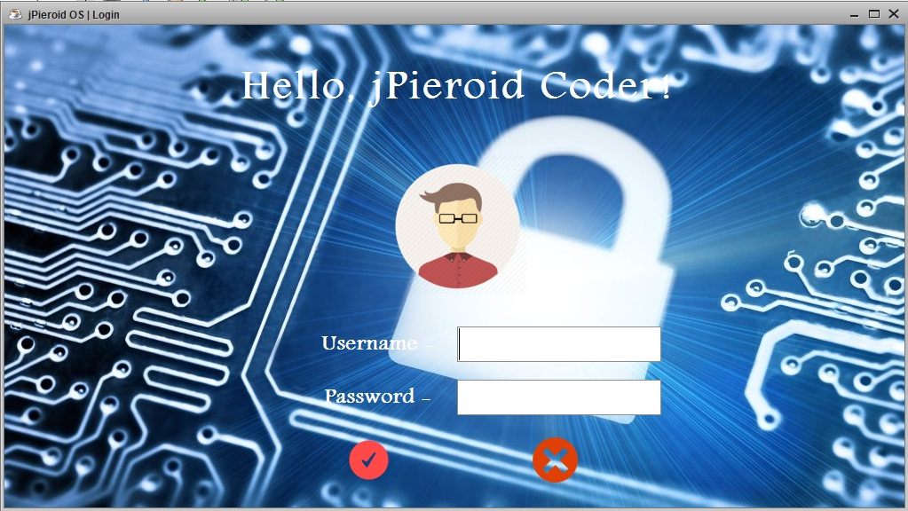

Coding of LOGIN.java

***LOGIN***

private void subbutton1ActionPerformed(java.awt.event.ActionEvent evt) {

String username = userTF.getText();

String pass = new String(passTF.getPassword());

if (username.equalsIgnoreCase(curusername) && pass.equalsIgnoreCase(curpassword)) {

JOptionPane.showMessageDialog(this,"You have been successfully logged in." );

home.setVisible(true);

this.dispose();

} else {

JOptionPane.showMessageDialog(this, "Password and User ID do not match. Please try again.", "Incorrect username or password", JOptionPane.ERROR\_MESSAGE);

}

}

***LOGOUT***

private void cancelbutton1ActionPerformed(java.awt.event.ActionEvent evt) {

if (JOptionPane.showConfirmDialog(this, "Are you sure you want to exit?", "Confirmation", JOptionPane.YES\_NO\_OPTION) == JOptionPane.YES\_OPTION) {

System.exit(0);

}

}

**2.HOME SCREEN**

**Frame: Home.java**

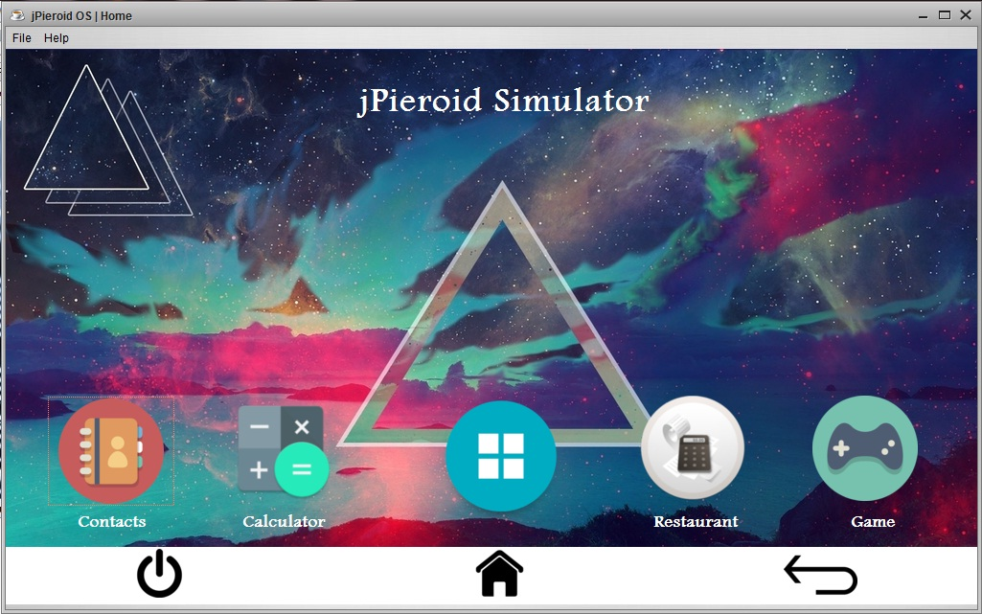

Coding of home.java

***APP***

private void appbuttonActionPerformed(java.awt.event.ActionEvent evt) {

appdrawer.dispose();

appdrawer.setVisible(true);

home.setVisible(false);

}

***POWER***

private void powbuttonActionPerformed(java.awt.event.ActionEvent evt) {

if (JOptionPane.showConfirmDialog(this, "Are you sure you want to exit?", "Confirmation", JOptionPane.YES\_NO\_OPTION) == JOptionPane.YES\_OPTION) {

System.exit(0);

}

}

**3.APPS SCREEN**

**Frame: apps.java**

**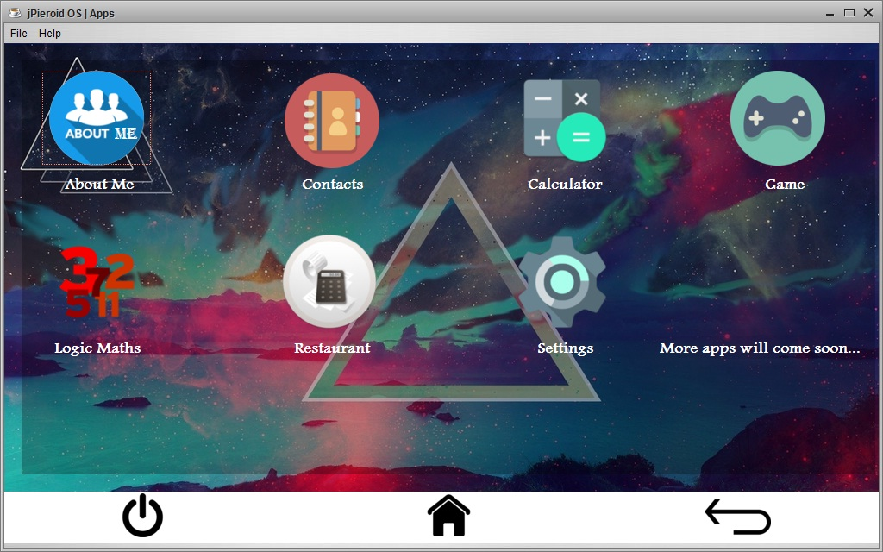**

Coding of APPS.java

***ABOUT*** ***ME***

private void aboutbuttonActionPerformed(java.awt.event.ActionEvent evt) {

aboutus.setVisible(true);

}

***CONTACTS***

private void contactbuttonActionPerformed(java.awt.event.ActionEvent evt) {

contacts.setVisible(true);

appdrawer.dispose();

}

***CALCULATOR***

private void calcbuttonActionPerformed(java.awt.event.ActionEvent evt) {

calculator.setVisible(true);

appdrawer.setVisible(false);

}

***GAME***

private void gamebuttonActionPerformed(java.awt.event.ActionEvent evt) {

bullsandcows.setVisible(true);

jd1.setVisible(true);

appdrawer.dispose();

}

***LOGIC*** ***MATHS***

private void npbuttonActionPerformed(java.awt.event.ActionEvent evt) {

nextprime.setVisible(true);

appdrawer.setVisible(false)

}

***RESTAURANT***

private void billbuttonActionPerformed(java.awt.event.ActionEvent evt) {

gblogin.setVisible(true);

appdrawer.setVisible(false);

}

***SETTINGS***

private void billbuttonActionPerformed(java.awt.event.ActionEvent evt) {

gblogin.setVisible(true);

appdrawer.setVisible(false);

}

***HOME***

private void homebutton1ActionPerformed(java.awt.event.ActionEvent evt) {

home.setVisible(true);

appdrawer.dispose();

}

**3.1 ABOUT ME**

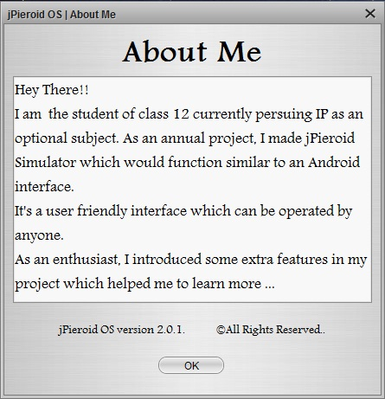

private void jButton5ActionPerformed(java.awt.event.ActionEvent evt) {

aboutus.dispose();

}

**3.2 CONTACTS**

**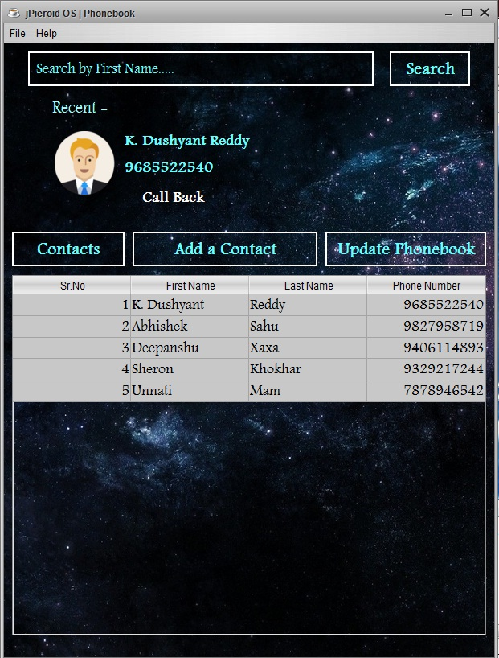**

***CONTACTS***

private void ContactbuttonActionPerformed(java.awt.event.ActionEvent evt) {

addcontact.setVisible(false);

updatepanel.setVisible(false);

contactpanel.setVisible(true);

DefaultTableModel tb = (DefaultTableModel) cnttb.getModel();

try {

tb.setRowCount(0);

Class.forName("java.sql.Driver");

Connection con = DriverManager.getConnection("jdbc:mysql://localhost:3306/jos", "root", "bps");

Statement stmt = con.createStatement();

String query = "Select \* from contacts";

ResultSet rs = stmt.executeQuery(query);

while (rs.next()) {

int srno = rs.getInt(1);

String fname = rs.getString(2);

String lname = rs.getString(3);

BigInteger num = new BigInteger(rs.getString(4));

tb.addRow(new Object[]{srno, fname, lname, num});

}

} catch (Exception e) {

System.out.println("Error in connectivity");

}

}

***ADD*** ***A*** ***CONTACT***

private void addcntbuttonActionPerformed(java.awt.event.ActionEvent evt) {

addcontact.setVisible(true);

contactpanel.setVisible(false);

updatepanel.setVisible(false);

}

***UPDATE*** ***A*** ***PHONEBOOK***

private void updatebuttonActionPerformed(java.awt.event.ActionEvent evt) {

addcontact.setVisible(false);

contactpanel.setVisible(false);

updatepanel.setVisible(true);

}

***SEARCH***

private void searchbuttonActionPerformed(java.awt.event.ActionEvent evt) {

String name = searchtf.getText();

try {

Class.forName("java.sql.Driver");

Connection con = DriverManager.getConnection("jdbc:mysql://localhost:3306/jos", "root", "bps");

Statement stmt = con.createStatement();

String query = "Select \* from contacts where first\_name='" + name + "'";

ResultSet rs = stmt.executeQuery(query);

if (rs.next()) {

int count = 1;

while (rs.next()) {

count++;

}

String query1 = "Select \* from contacts where first\_name='" + name + "'";

ResultSet rs1 = stmt.executeQuery(query1);

if (count == 1) {

rs1.next();

delsrno = rs1.getInt(1);

details.setVisible(true);

String fname = rs1.getString(2);

String lname = rs1.getString(3);

namelbl.setText(fname + " " + lname);

BigInteger num = new BigInteger(rs1.getString(4));

numlbl.setText("" + num);

} else {

tbdetails.setVisible(true);

DefaultTableModel tb = (DefaultTableModel) dtb.getModel();

while (rs1.next()) {

int srno = rs1.getInt(1);

String fname = rs1.getString(2);

String lname = rs1.getString(3);

BigInteger num = new BigInteger(rs1.getString(4));

tb.addRow(new Object[]{srno, fname, lname, num});

}

rs1.close();

}

} else {

JOptionPane.showMessageDialog(this, "No Contact with such name exists", "No Contact found", JOptionPane.ERROR\_MESSAGE);

}

con.close();

stmt.close();

rs.close();

searchtf.setText(" Search by First Name.....");

} catch (Exception e) {

System.out.println("Error in connectivity");

}

}

***CALL*** ***BACK***

private void cbbutnActionPerformed(java.awt.event.ActionEvent evt) {

JOptionPane.showMessageDialog(null, "Sorry you have no SIM Card in phone. Please insert a SIM to call", "No SIM Card Detected", JOptionPane.ERROR\_MESSAGE);

}

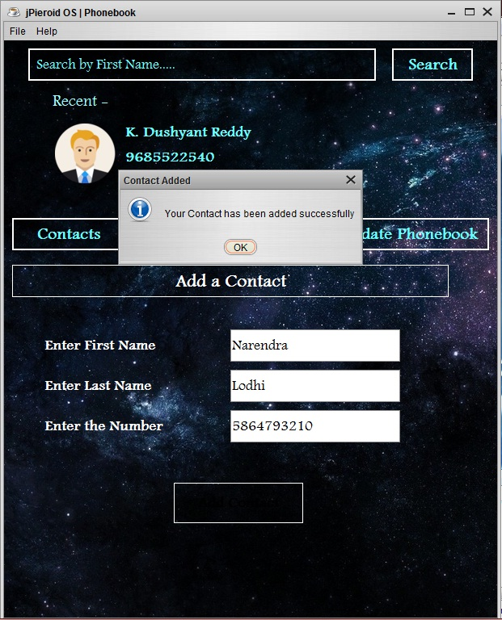

***ADD*** ***CONTACT***

private void addcntctActionPerformed(java.awt.event.ActionEvent evt) {

BigInteger num = new BigInteger(numtf1.getText());

String fname = fnametf.getText();

String lname = lnametf.getText();

try {

Class.forName("java.sql.Driver");

Connection con = DriverManager.getConnection("jdbc:mysql://localhost:3306/jos", "root", "bps");

Statement stmt = con.createStatement();

String query = "Select max(Sr\_No) from contacts";

ResultSet rs1 = stmt.executeQuery(query);

rs1.next();

int srno = rs1.getInt(1) + 1;

String query2 = "Insert into contacts values(" + srno + ",'" + fname + "','" + lname + "'," + num + ")";

stmt.executeUpdate(query2);

JOptionPane.showMessageDialog(this, "Your Contact has been added successfully", "Contact Added", JOptionPane.INFORMATION\_MESSAGE);

numtf1.setText("");

lnametf.setText("");

fnametf.setText("");

} catch (Exception e) {

System.out.println("Error in connectivity");

}

}

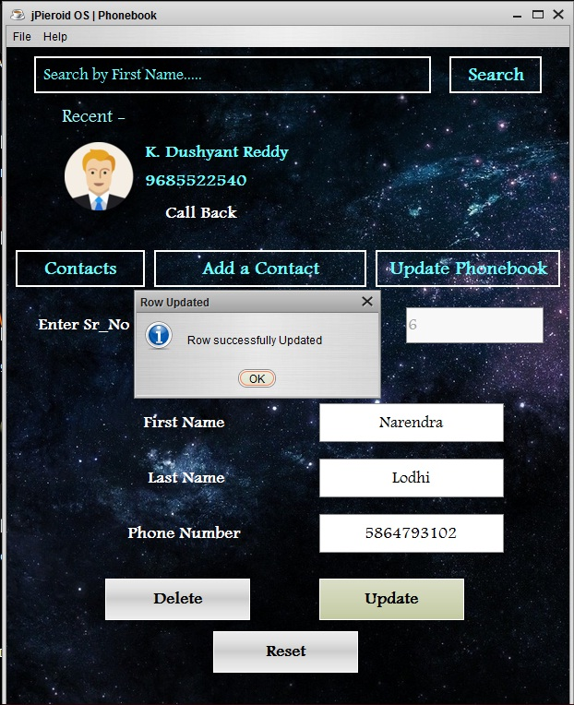

***UPDATE***

private void upbuttonActionPerformed(java.awt.event.ActionEvent evt) {

int srno = Integer.parseInt(srnotf.getText());

String fname = ufnametf.getText();

String lname = ulnametf.getText();

BigInteger num = new BigInteger(unumtf.getText());

try {

Class.forName("java.sql.Driver");

Connection con = DriverManager.getConnection("jdbc:mysql://localhost:3306/jos", "root", "bps");

Statement stmt = con.createStatement();

String query = "Update contacts set first\_name='" + fname + "',last\_name='" + lname + "',number=" + num + " where sr\_no=" + srno;

int n = stmt.executeUpdate(query);

JOptionPane.showMessageDialog(this, "Row successfully Updated", "Row Updated", JOptionPane.INFORMATION\_MESSAGE);

} catch (Exception e) {

System.out.println("Error in connectivity");

}

}

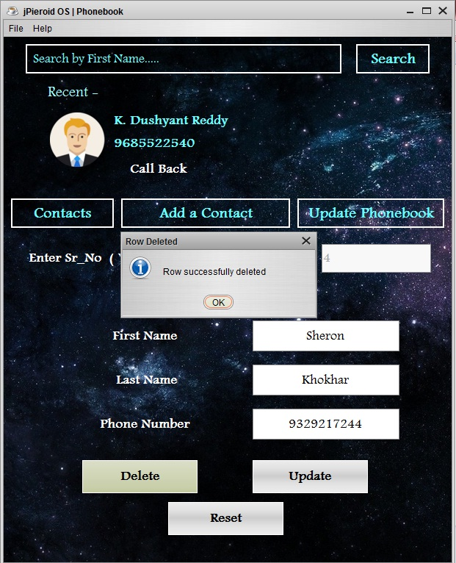

***DELETE***

private void delbuttonActionPerformed(java.awt.event.ActionEvent evt) {

int srno = Integer.parseInt(srnotf.getText());

try {

Class.forName("java.sql.Driver");

Connection con = DriverManager.getConnection("jdbc:mysql://localhost:3306/jos", "root", "bps");

Statement stmt = con.createStatement();

String query = "Delete from contacts where sr\_no=" + srno;

if ((JOptionPane.showConfirmDialog(null, "Are you sure you want to delete this record?", "Delete Record", JOptionPane.YES\_NO\_OPTION)) == JOptionPane.YES\_OPTION) {

int n = stmt.executeUpdate(query);

if (n == 0) {

JOptionPane.showMessageDialog(this, "Row does not exist", "No Row Remaining", JOptionPane.ERROR\_MESSAGE);

} else {

JOptionPane.showMessageDialog(this, "Row successfully deleted", "Row Deleted", JOptionPane.INFORMATION\_MESSAGE);

}

}

} catch (Exception e) {

System.out.println("Error in connectivity");

}

}

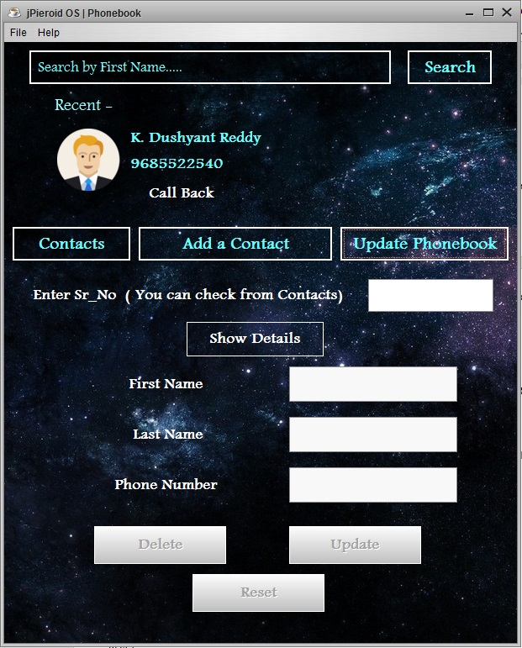

***SHOW*** ***DETAILS***

private void shbuttonActionPerformed(java.awt.event.ActionEvent evt) {

if (srnotf.getText().equals("")) {

JOptionPane.showMessageDialog(this, "Please Enter a Sr.No to get details!!", "Wrong Sr\_No", JOptionPane.ERROR\_MESSAGE);

} else {

int srno = Integer.parseInt(srnotf.getText());

try {

Class.forName("java.sql.Driver");

Connection con = DriverManager.getConnection("jdbc:mysql://localhost:3306/jos", "root", "bps");

Statement stmt = con.createStatement();

String query = "Select Sr\_No from contacts where Sr\_No=" + srno;

ResultSet rs = stmt.executeQuery(query);

if (rs.next()) {

String query2 = "Select \* from contacts where Sr\_no=" + srno;

ResultSet rs1 = stmt.executeQuery(query2);

rs1.next();

String uname = rs1.getString(2);

String lname = rs1.getString(3);

ufnametf.setText(uname);

ulnametf.setText(lname);

BigInteger num = new BigInteger(rs1.getString(4));

unumtf.setText("" + num);

delbutton.setEnabled(true);

jLabel9.setEnabled(true);

jLabel10.setEnabled(true);

jLabel8.setEnabled(true);

upbutton.setEnabled(true);

ufnametf.setEnabled(true);

ulnametf.setEnabled(true);

unumtf.setEnabled(true);

srnotf.setEnabled(false);

resetbutton.setEnabled(true);

} else {

JOptionPane.showMessageDialog(this, "You have entered wrong Serial Number!!. Please enter the correct number", "Wrong Sr\_No", JOptionPane.ERROR\_MESSAGE);

}

} catch (Exception e) {

System.out.println("Error in connectivity");

}

}

}

***RESET***

private void resetbuttonActionPerformed(java.awt.event.ActionEvent evt) {

delbutton.setEnabled(false);

jLabel9.setEnabled(false);

jLabel10.setEnabled(false);

jLabel8.setEnabled(false);

upbutton.setEnabled(false);

ufnametf.setEnabled(false);

ulnametf.setEnabled(false);

unumtf.setEnabled(false);

srnotf.setEnabled(true);

resetbutton.setEnabled(false);

ufnametf.setText("");

ulnametf.setText("");

unumtf.setText("");

srnotf.setText("");

}

**3.3 CALCULATOR**

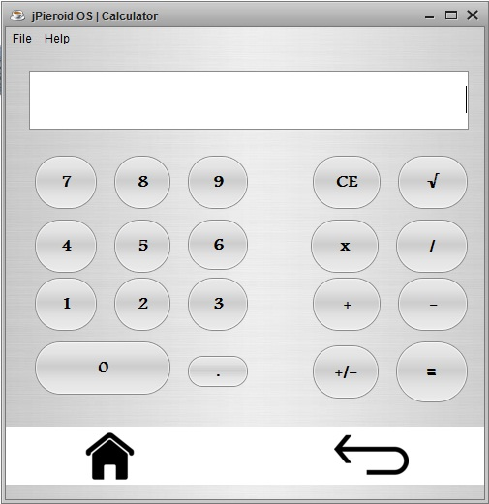

***DECIMAL***

private void jButton17ActionPerformed(java.awt.event.ActionEvent evt) {

if(! t.getText().contains("."))

{t.setText(t.getText() + jButton17.getText());

}

}

***NUM*** ***–*** ***0***

private void b0ActionPerformed(java.awt.event.ActionEvent evt) {

String a = t.getText();

if(a == ""){

t.setText(b0.getText()); }

else{

a=t.getText() + b0.getText();

t.setText(a);

}

}

***NUM*** ***–*** ***1***

private void b1ActionPerformed(java.awt.event.ActionEvent evt) {

String a = t.getText();

if(a == ""){

t.setText(b1.getText()); }

else{

a=t.getText() + b1.getText();

t.setText(a);

}

}

***NUM*** ***–*** ***2***

private void b2ActionPerformed(java.awt.event.ActionEvent evt) {

String a = t.getText();

if(a == ""){

t.setText(b2.getText()); }

else{

a=t.getText() + b2.getText();

t.setText(a);

}

}

***NUM – 3***

private void b3ActionPerformed(java.awt.event.ActionEvent evt) {

String a = t.getText();

if(a == ""){

t.setText(b3.getText()); }

else{

a=t.getText() + b3.getText();

t.setText(a);

}

}

***NUM – 4***

private void b4ActionPerformed(java.awt.event.ActionEvent evt) {

String a = t.getText();

if(a == ""){

t.setText(b4.getText()); }

else{

a=t.getText() + b4.getText();

t.setText(a);

}

}

***NUM – 5***

private void b5ActionPerformed(java.awt.event.ActionEvent evt) {

String a = t.getText();

if(a == ""){

t.setText(b5.getText()); }

else{

a=t.getText() + b5.getText();

t.setText(a);

}

}

***NUM – 6***

private void b6ActionPerformed(java.awt.event.ActionEvent evt) {

String a = t.getText();

if(a == ""){

t.setText(b6.getText()); }

else{

a=t.getText() + b6.getText();

t.setText(a);

}

}

***NUM – 7***

private void b7ActionPerformed(java.awt.event.ActionEvent evt) {

String a = t.getText();

if(a == ""){

t.setText(b7.getText()); }

else{

a=t.getText() + b7.getText();

t.setText(a);

}

}

***NUM – 8***

private void b8ActionPerformed(java.awt.event.ActionEvent evt) {

String a = t.getText();

if(a == ""){

t.setText(b8.getText()); }

else{

a=t.getText() + b8.getText();

t.setText(a);

}

}

***NUM – 9***

private void b9ActionPerformed(java.awt.event.ActionEvent evt) {

String a = t.getText();

if(a == ""){

t.setText(b9.getText()); }

else{

a=t.getText() + b9.getText();

t.setText(a);

}

}

***CE***

private void jButton21ActionPerformed(java.awt.event.ActionEvent evt) {

t.setText("");

}

***SQUAREROOT***

private void jButton22ActionPerformed(java.awt.event.ActionEvent evt) {

double as = Double.parseDouble(String.valueOf(t.getText()));

as = Math.sqrt(as);

t.setText(String.valueOf(as));

}

***MULTIPLY***

private void jButton13ActionPerformed(java.awt.event.ActionEvent evt) {

firstnum = Double.parseDouble(t.getText());

t.setText("");

operations="\*";

}

***DIVIDE***

private void jButton19ActionPerformed(java.awt.event.ActionEvent evt) {

firstnum = Double.parseDouble(t.getText());

t.setText("");

operations="/";

}

***ADD***

private void jButton14ActionPerformed(java.awt.event.ActionEvent evt) {

firstnum = Double.parseDouble(t.getText());

t.setText("");

operations="+";

}

***SUBTRACT***

private void jButton12ActionPerformed(java.awt.event.ActionEvent evt) {

firstnum = Double.parseDouble(t.getText());

t.setText("");

operations="-";

}

***ADD/SUBTRACT***

private void jButton20ActionPerformed(java.awt.event.ActionEvent evt) {

double as = Double.parseDouble(String.valueOf(t.getText()));

as = as \* (-1);

t.setText(String.valueOf(as));

}

***EQUAL***

private void jButton16ActionPerformed(java.awt.event.ActionEvent evt) {

String ans;

secondnum = Double.parseDouble(t.getText());

if(operations =="+")

{

result = firstnum + secondnum;

ans = String.format("%.2f" , result);

t.setText( ans);

}

else if (operations == "-")

{

result = firstnum - secondnum;

ans = String.format("%.2f" , result);

t.setText( ans);

}

else if (operations == "\*")

{

result = firstnum \* secondnum;

ans = String.format("%.2f" , result);

t.setText( ans);

}

else if (operations == "/")

{

result = firstnum / secondnum;

ans = String.format("%.2f" , result);

t.setText( ans);

}

}

**3.4 GAME**

**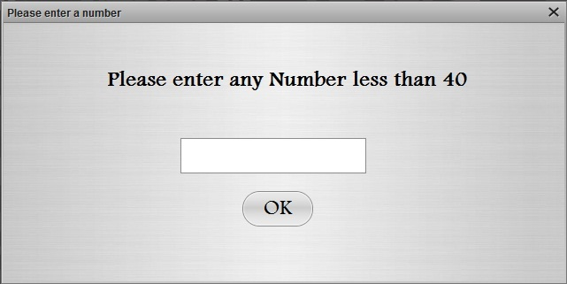**

private void jButton18ActionPerformed(java.awt.event.ActionEvent evt) {

try {

int num = Integer.parseInt(numtf.getText());

if (num > 40) {

JOptionPane.showMessageDialog(this, "Please enter a number less than 40", "Wrong Input", JOptionPane.WARNING\_MESSAGE);

numtf.setText("");

} else {

wordcount = num;

jd1.dispose();

numtf.setText("");

}

} catch (NumberFormatException e) {

JOptionPane.showMessageDialog(this, "Your input is invalid.", "Invalid Input", JOptionPane.ERROR\_MESSAGE);

}

}

**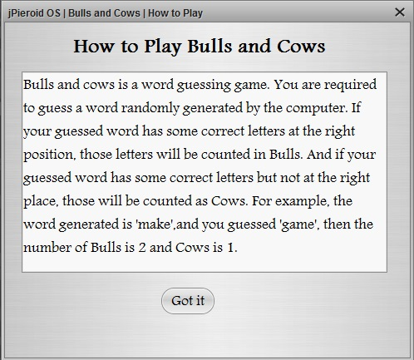**

private void jButton15ActionPerformed(java.awt.event.ActionEvent evt) {

howtoplay.dispose();

}

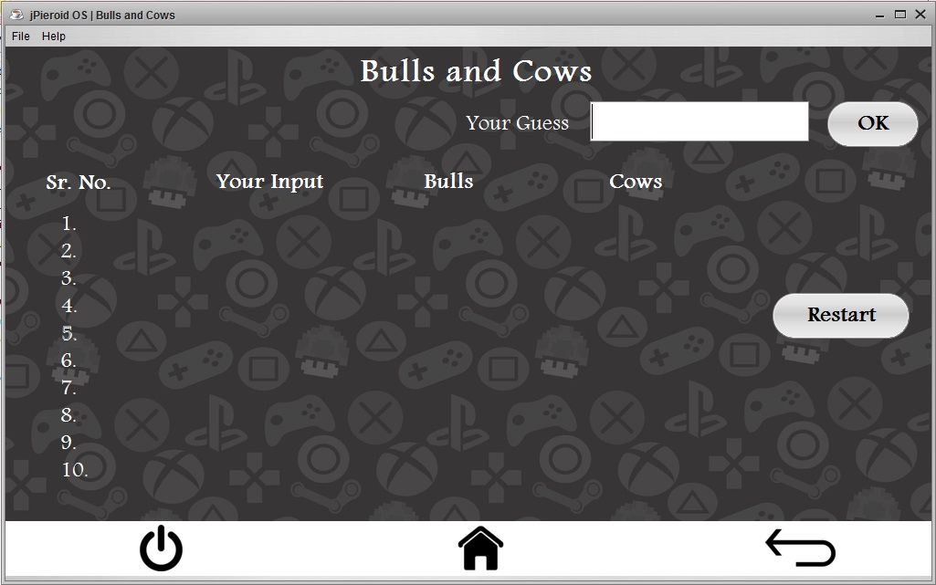

private void okbuttonActionPerformed(java.awt.event.ActionEvent evt) {

String input = inputTF.getText();

if (input.length() != 4) {

JOptionPane.showMessageDialog(this, "Please enter a 4 digit word");

inputTF.setText("");

} else {

if (trycount <= 10) {

int bulls = 0;

int cows = 0;

String word = new String();

char inputch;

char wordch;

try {

Class.forName("java.sql.Driver");

Connection con = DriverManager.getConnection("jdbc:mysql://localhost:3306/jos", "root", "bps");

Statement stmt = con.createStatement();

String query = "Select word from words where srno=" + wordcount;

ResultSet rs = stmt.executeQuery(query);

if (rs.first()) {

word = rs.getString(1);

}

} catch (Exception e) {

System.out.println("Error");

}

for (int i = 0; i < word.length(); i++) {

for (int j = 0; j < input.length();) {

wordch = word.charAt(i);

if (i == j) {

j++;

} else {

inputch = input.charAt(j);

if (inputch == wordch) {

cows++;

}

j++;

}

}

}

for (int i = 0; i < word.length(); i++) {

wordch = word.charAt(i);

inputch = input.charAt(i);

if (inputch == wordch) {

bulls++;

}

}

if (trycount == 1) {

inputlabel1.setText(input);

bullslabel1.setText(bulls + "");

cowslabel1.setText(cows + "");

} else if (trycount == 2) {

inputlabel2.setText(input);

bullslabel2.setText(bulls + "");

cowslabel2.setText(cows + "");

} else if (trycount == 3) {

inputlabel3.setText(input);

bullslabel3.setText(bulls + "");

cowslabel3.setText(cows + "");

} else if (trycount == 4) {

inputlabel4.setText(input);

bullslabel4.setText(bulls + "");

cowslabel4.setText(cows + "");

} else if (trycount == 5) {

inputlabel5.setText(input);

bullslabel5.setText(bulls + "");

cowslabel5.setText(cows + "");

} else if (trycount == 6) {

inputlabel6.setText(input);

bullslabel6.setText(bulls + "");

cowslabel6.setText(cows + "");

} else if (trycount == 7) {

inputlabel7.setText(input);

bullslabel7.setText(bulls + "");

cowslabel7.setText(cows + "");

} else if (trycount == 8) {

inputlabel8.setText(input);

bullslabel8.setText(bulls + "");

cowslabel8.setText(cows + "");

} else if (trycount == 9) {

inputlabel9.setText(input);

bullslabel9.setText(bulls + "");

cowslabel9.setText(cows + "");

} else if (trycount == 10) {

inputlabel10.setText(input);

bullslabel10.setText(bulls + "");

cowslabel10.setText(cows + "");

}

if (trycount == 10 && bulls != 4) {

JOptionPane.showMessageDialog(this, "Sorry! You lost. The word is- " + word + ".", "You Lost", JOptionPane.PLAIN\_MESSAGE);

inputTF.setText("");

inputlabel1.setText("");

bullslabel1.setText("");

cowslabel1.setText("");

inputlabel2.setText("");

bullslabel2.setText("");

cowslabel2.setText("");

inputlabel3.setText("");

bullslabel3.setText("");

cowslabel3.setText("");

inputlabel4.setText("");

bullslabel4.setText("");

cowslabel4.setText("");

inputlabel5.setText("");

bullslabel5.setText("");

cowslabel5.setText("");

inputlabel6.setText("");

bullslabel6.setText("");

cowslabel6.setText("");

inputlabel7.setText("");

bullslabel7.setText("");

cowslabel7.setText("");

inputlabel8.setText("");

bullslabel8.setText("");

cowslabel8.setText("");

inputlabel9.setText("");

bullslabel9.setText("");

cowslabel9.setText("");

inputlabel10.setText("");

bullslabel10.setText("");

cowslabel10.setText("");

trycount = 0;

if (wordcount <= 40) {

wordcount++;

} else {

wordcount = 1;

}

}

trycount++;

if (bulls == 4) {

JOptionPane.showMessageDialog(this, "You got that!", "You won", JOptionPane.PLAIN\_MESSAGE);

inputTF.setText("");

inputlabel1.setText("");

bullslabel1.setText("");

cowslabel1.setText("");

inputlabel2.setText("");

bullslabel2.setText("");

cowslabel2.setText("");

inputlabel3.setText("");

bullslabel3.setText("");

cowslabel3.setText("");

inputlabel4.setText("");

bullslabel4.setText("");

cowslabel4.setText("");

inputlabel5.setText("");

bullslabel5.setText("");

cowslabel5.setText("");

inputlabel6.setText("");

bullslabel6.setText("");

cowslabel6.setText("");

inputlabel7.setText("");

bullslabel7.setText("");

cowslabel7.setText("");

inputlabel8.setText("");

bullslabel8.setText("");

cowslabel8.setText("");

inputlabel9.setText("");

bullslabel9.setText("");

cowslabel9.setText("");

inputlabel10.setText("");

bullslabel10.setText("");

cowslabel10.setText("");

trycount = 1;

if (wordcount <= 40) {

wordcount++;

} else {

wordcount = 1;

}

}

} else {

JOptionPane.showMessageDialog(this, "Sorry! You have no more tries left..", "No tries left", JOptionPane.WARNING\_MESSAGE);

}

}

}

***RESET***

private void restartbtnActionPerformed(java.awt.event.ActionEvent evt) {

inputTF.setText("");

inputlabel1.setText("");

bullslabel1.setText("");

cowslabel1.setText("");

inputlabel2.setText("");

bullslabel2.setText("");

cowslabel2.setText("");

inputlabel3.setText("");

bullslabel3.setText("");

cowslabel3.setText("");

inputlabel4.setText("");

bullslabel4.setText("");

cowslabel4.setText("");

inputlabel5.setText("");

bullslabel5.setText("");

cowslabel5.setText("");

inputlabel6.setText("");

bullslabel6.setText("");

cowslabel6.setText("");

inputlabel7.setText("");

bullslabel7.setText("");

cowslabel7.setText("");

inputlabel8.setText("");

bullslabel8.setText("");

cowslabel8.setText("");

inputlabel9.setText("");

bullslabel9.setText("");

cowslabel9.setText("");

inputlabel10.setText("");

bullslabel10.setText("");

cowslabel10.setText("");

trycount = 1;

if (wordcount <= 40) {

wordcount++;

} else {

wordcount = 1;

}

}

**3.5 LOGIC MATHS**

**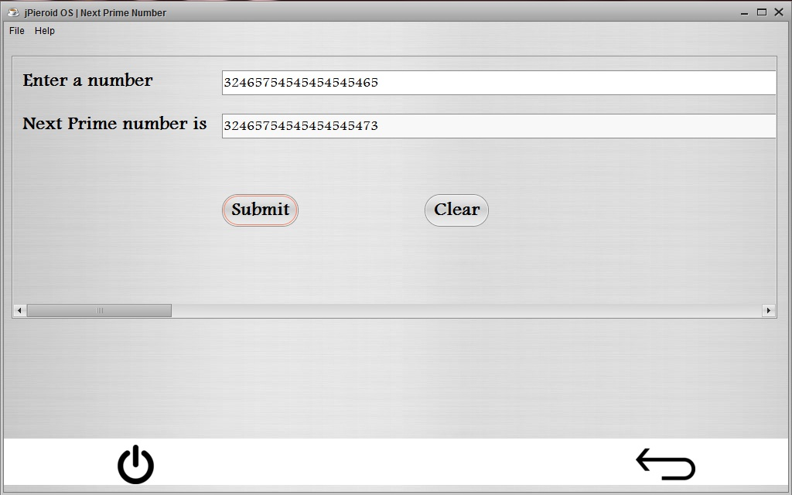**

***SUBMIT***

private void jButton3ActionPerformed(java.awt.event.ActionEvent evt) {

BigInteger n = new BigInteger(t1.getText());

BigInteger p = new BigInteger("" + n.nextProbablePrime());

t2.setText(p + "");

}

***CLEAR***

private void jButton4ActionPerformed(java.awt.event.ActionEvent evt) {

t2.setText("");

t1.setText("");

}

**3.6 RESTAURANT**

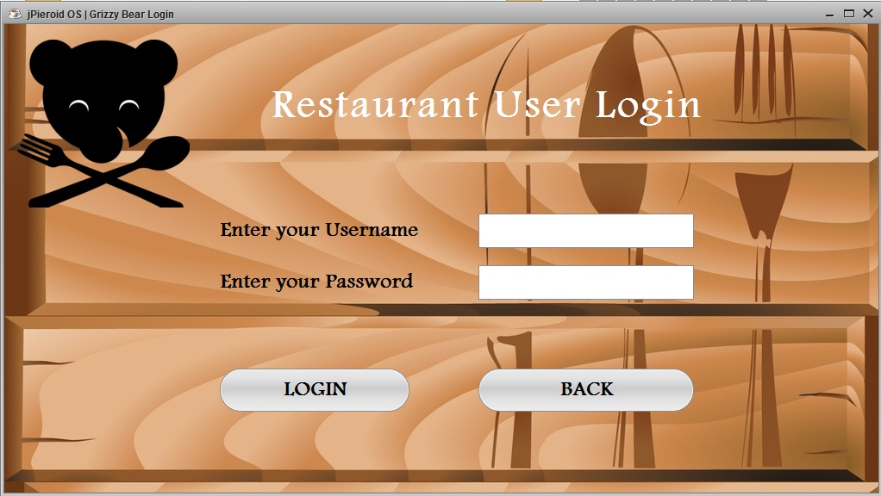

***LOGIN***

private void jButton9ActionPerformed(java.awt.event.ActionEvent evt) {

String gbuser = gbuserTF.getText();

String gbpass = new String(gbpassPF.getPassword());

if (gbuser.equalsIgnoreCase(curusername) && gbpass.equalsIgnoreCase(curpassword)) {

JOptionPane.showMessageDialog(this, "You have been successfully logged in");

billing.setVisible(true);

gblogin.dispose();

} else {

JOptionPane.showMessageDialog(this, "Your USERNAME or PASSWORD is incorrect. Please try again ", "Wrong Username or Password", JOptionPane.ERROR\_MESSAGE);

}

}

***BACK***

private void jButton10ActionPerformed(java.awt.event.ActionEvent evt) {

appdrawer.setVisible(true);

gblogin.dispose();

}

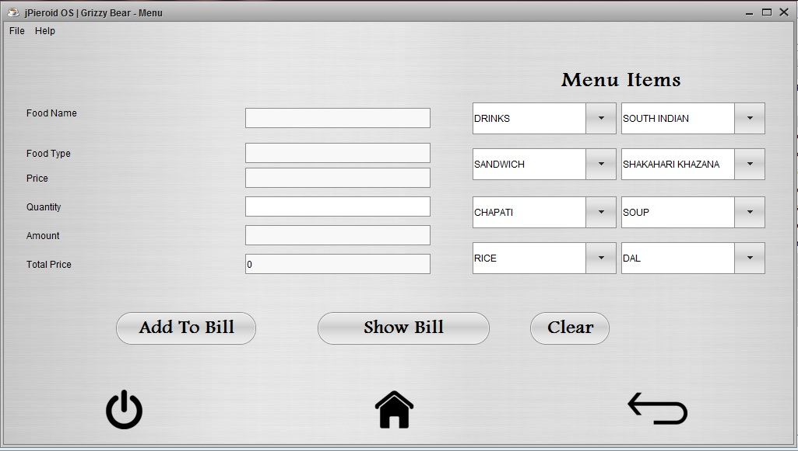

***ADD*** ***TO*** ***BILL***

private void jButton6ActionPerformed(java.awt.event.ActionEvent evt) {

int amount = Integer.parseInt(famountTF.getText());

int Tprice = Integer.parseInt(ftpriceTF.getText());

DefaultTableModel billtm = (DefaultTableModel) billTB.getModel();

billtm.addRow(new Object[]{fnameTF.getText(), FpriceTF.getText(), FquantityTF.getText(), famountTF.getText()});

ftpriceTF.setText("" + (Tprice + amount));

totalamtTF.setText("" + (Tprice + amount));

}

***SHOW*** ***BILL***

private void jButton7ActionPerformed(java.awt.event.ActionEvent evt) {

billtable.setVisible(true);

}

***CLEAR***

private void jButton11ActionPerformed(java.awt.event.ActionEvent evt) {

fnameTF.setText("");

ftypeTF.setText("");

FpriceTF.setText("");

FquantityTF.setText("");

famountTF.setText("");

ftpriceTF.setText("0");

}

***DRINKS***

private void drinksCmBItemStateChanged(java.awt.event.ItemEvent evt) {

int food = drinksCmB.getSelectedIndex();

if (food == 1) {

fnameTF.setText("");

ftypeTF.setText("");

FpriceTF.setText("");

fnameTF.setText("Tea");

ftypeTF.setText("Drinks");

FpriceTF.setText("" + 20);

} else if (food == 2) {

fnameTF.setText("");

ftypeTF.setText("");

FpriceTF.setText("");

fnameTF.setText("Coffee");

ftypeTF.setText("Drinks");

FpriceTF.setText("" + 25);

} else if (food == 3) {

fnameTF.setText("");

ftypeTF.setText("");

FpriceTF.setText("");

fnameTF.setText("Soda");

ftypeTF.setText("Drinks");

FpriceTF.setText("" + 15);

} else if (food == 4) {

fnameTF.setText("");

ftypeTF.setText("");

FpriceTF.setText("");

fnameTF.setText("Soft Drink");

ftypeTF.setText("Drinks");

FpriceTF.setText("" + 35);

} else if (food == 5) {

fnameTF.setText("");

ftypeTF.setText("");

FpriceTF.setText("");

fnameTF.setText("Lime Soda");

ftypeTF.setText("Drinks");

FpriceTF.setText("" + 25);

} else if (food == 6) {

fnameTF.setText("");

ftypeTF.setText("");

FpriceTF.setText("");

fnameTF.setText("Vanilla Shake");

ftypeTF.setText("Drinks");

FpriceTF.setText("" + 60);

} else if (food == 7) {

fnameTF.setText("");

ftypeTF.setText("");

FpriceTF.setText("");

fnameTF.setText("Chocolate Shake");

ftypeTF.setText("Drinks");

FpriceTF.setText("" + 60);

} else if (food == 8) {

fnameTF.setText("");

ftypeTF.setText("");

FpriceTF.setText("");

fnameTF.setText("Strawberry Shake");

ftypeTF.setText("Drinks");

FpriceTF.setText("" + 60);

}

FquantityTF.setText("");

famountTF.setText("");

}

***SOUTH*** ***INDIAN***

private void SouthCmBItemStateChanged(java.awt.event.ItemEvent evt) {

int food = SouthCmB.getSelectedIndex();

if (food == 1) {

fnameTF.setText("");

ftypeTF.setText("");

FpriceTF.setText("");

fnameTF.setText("Sada Dosa");

ftypeTF.setText("South Indian");

FpriceTF.setText("" + 50);

} else if (food == 2) {

fnameTF.setText("");

ftypeTF.setText("");

FpriceTF.setText("");

fnameTF.setText("Masala Dosa");

ftypeTF.setText("South Indian");

FpriceTF.setText("" + 60);

} else if (food == 3) {

fnameTF.setText("");

ftypeTF.setText("");

FpriceTF.setText("");

fnameTF.setText("Uttapam");

ftypeTF.setText("South Indian");

FpriceTF.setText("" + 55);

} else if (food == 4) {

fnameTF.setText("");

ftypeTF.setText("");

FpriceTF.setText("");

fnameTF.setText("Rava Dosa");

ftypeTF.setText("South Indian");

FpriceTF.setText("" + 55);

} else if (food == 5) {

fnameTF.setText("");

ftypeTF.setText("");

FpriceTF.setText("");

fnameTF.setText("Rava Masala");

ftypeTF.setText("South Indian");

FpriceTF.setText("" + 65);

} else if (food == 6) {

fnameTF.setText("");

ftypeTF.setText("");

FpriceTF.setText("");

fnameTF.setText("Spring Masala");

ftypeTF.setText("South Indian");

FpriceTF.setText("" + 75);

}

FquantityTF.setText("");

famountTF.setText("");

}

***SANDWICH***

private void sandwichCmBItemStateChanged(java.awt.event.ItemEvent evt) {

int food = sandwichCmB.getSelectedIndex();

if (food == 1) {

fnameTF.setText("");

ftypeTF.setText("");

FpriceTF.setText("");

fnameTF.setText("Veg Sandwich");

ftypeTF.setText("Sandwich");

FpriceTF.setText("" + 40);

} else if (food == 2) {

fnameTF.setText("");

ftypeTF.setText("");

FpriceTF.setText("");

fnameTF.setText("Chatni Sandwich");

ftypeTF.setText("Sandwich");

FpriceTF.setText("" + 30);

} else if (food == 3) {

fnameTF.setText("");

ftypeTF.setText("");

FpriceTF.setText("");

fnameTF.setText("Omlet Sandwich");

ftypeTF.setText("Sandwich");

FpriceTF.setText("" + 55);

} else if (food == 4) {

fnameTF.setText("");

ftypeTF.setText("");

FpriceTF.setText("");

fnameTF.setText("Cheese Sandwich");

ftypeTF.setText("Sandwich");

FpriceTF.setText("" + 70);

} else if (food == 5) {

fnameTF.setText("");

ftypeTF.setText("");

FpriceTF.setText("");

fnameTF.setText("Club Sandwich");

ftypeTF.setText("Sandwich");

FpriceTF.setText("" + 80);

} else if (food == 6) {

fnameTF.setText("");

ftypeTF.setText("");

FpriceTF.setText("");

fnameTF.setText("Veg Grill Sandwich");

ftypeTF.setText("Sandwich");

FpriceTF.setText("" + 65);

} else if (food == 7) {

fnameTF.setText("");

ftypeTF.setText("");

FpriceTF.setText("");

fnameTF.setText("Diamond Club Sandwich");

ftypeTF.setText("Sandwich");

FpriceTF.setText("" + 100);

}

FquantityTF.setText("");

famountTF.setText("");

}

***SHAKAHARI*** ***KHAZANA***

private void vegCmBItemStateChanged(java.awt.event.ItemEvent evt) {

int food = vegCmB.getSelectedIndex();

if (food == 1) {

fnameTF.setText("");

ftypeTF.setText("");

FpriceTF.setText("");

fnameTF.setText("Veg Handi");

ftypeTF.setText("Shakahari Khazana");

FpriceTF.setText("" + 145);

}

if (food == 2) {

fnameTF.setText("");

ftypeTF.setText("");

FpriceTF.setText("");

fnameTF.setText("Mix Vegetables");

ftypeTF.setText("Shakahari Khazana");

FpriceTF.setText("" + 120);

}

if (food == 3) {

fnameTF.setText("");

ftypeTF.setText("");

FpriceTF.setText("");

fnameTF.setText("Dum Alu");

ftypeTF.setText("Shakahari Khazana");

FpriceTF.setText("" + 135);

}

if (food == 4) {

fnameTF.setText("");

ftypeTF.setText("");

FpriceTF.setText("");

fnameTF.setText("Alu Mutter");

ftypeTF.setText("Shakahari Khazana");

FpriceTF.setText("" + 105);

}

if (food == 5) {

fnameTF.setText("");

ftypeTF.setText("");

FpriceTF.setText("");

fnameTF.setText("Karela Masala");

ftypeTF.setText("Shakahari Khazana");

FpriceTF.setText("" + 135);

}

if (food == 6) {

fnameTF.setText("");

ftypeTF.setText("");

FpriceTF.setText("");

fnameTF.setText("Chana Masala");

ftypeTF.setText("Shakahari Khazana");

FpriceTF.setText("" + 145);

}

if (food == 7) {

fnameTF.setText("");

ftypeTF.setText("");

FpriceTF.setText("");

fnameTF.setText("Paneer Tikka");

ftypeTF.setText("Shakahari Khazana");

FpriceTF.setText("" + 160);

}

if (food == 8) {

fnameTF.setText("");

ftypeTF.setText("");

FpriceTF.setText("");

fnameTF.setText("Chhole Bhatura");

ftypeTF.setText("Shakahari Khazana");

FpriceTF.setText("" + 140);

}

if (food == 9) {

fnameTF.setText("");

ftypeTF.setText("");

FpriceTF.setText("");

fnameTF.setText("Kaju Masala");

ftypeTF.setText("Shakahari Khazana");

FpriceTF.setText("" + 185);

}

if (food == 10) {

fnameTF.setText("");

ftypeTF.setText("");

FpriceTF.setText("");

fnameTF.setText("Mushroom Fry");

ftypeTF.setText("Shakahari Khazana");

FpriceTF.setText("" + 145);

}

FquantityTF.setText("");

famountTF.setText("");

}

***CHAPATI***

private void chappatiCmBItemStateChanged(java.awt.event.ItemEvent evt) {

int food = chappatiCmB.getSelectedIndex();

if (food == 1) {

fnameTF.setText("");

ftypeTF.setText("");

FpriceTF.setText("");

fnameTF.setText("Chapati");

ftypeTF.setText("Chapati");

FpriceTF.setText("" + 8);

}

if (food == 2) {

fnameTF.setText("");

ftypeTF.setText("");

FpriceTF.setText("");

fnameTF.setText("Roti");

ftypeTF.setText("Chapati");

FpriceTF.setText("" + 15);

}

if (food == 3) {

fnameTF.setText("");

ftypeTF.setText("");

FpriceTF.setText("");

fnameTF.setText("Paratha");

ftypeTF.setText("Chapati");

FpriceTF.setText("" + 24);

}

if (food == 4) {

fnameTF.setText("");

ftypeTF.setText("");

FpriceTF.setText("");

fnameTF.setText("Naan");

ftypeTF.setText("Chapati");

FpriceTF.setText("" + 25);

}

if (food == 5) {

fnameTF.setText("");

ftypeTF.setText("");

FpriceTF.setText("");

fnameTF.setText("Garlic Naan");

ftypeTF.setText("Chapati");

FpriceTF.setText("" + 50);

}

if (food == 6) {

fnameTF.setText("");

ftypeTF.setText("");

FpriceTF.setText("");

fnameTF.setText("Kashmiri Naan");

ftypeTF.setText("Chapati");

FpriceTF.setText("" + 50);

}

FquantityTF.setText("");

famountTF.setText("");

}

***SOUP***

private void soupCmBItemStateChanged(java.awt.event.ItemEvent evt) {

int food = soupCmB.getSelectedIndex();

if (food == 1) {

fnameTF.setText("");

ftypeTF.setText("");

FpriceTF.setText("");

fnameTF.setText("Tomato Soup");

ftypeTF.setText("Soup");

FpriceTF.setText("" + 85);

}

if (food == 2) {

fnameTF.setText("");

ftypeTF.setText("");

FpriceTF.setText("");

fnameTF.setText("Veg Manchow");

ftypeTF.setText("Soup");

FpriceTF.setText("" + 95);

}

if (food == 3) {

fnameTF.setText("");

ftypeTF.setText("");

FpriceTF.setText("");

fnameTF.setText("Veg Noddles");

ftypeTF.setText("Soup");

FpriceTF.setText("" + 90);

}

if (food == 4) {

fnameTF.setText("");

ftypeTF.setText("");

FpriceTF.setText("");

fnameTF.setText("Palak Soup");

ftypeTF.setText("Soup");

FpriceTF.setText("" + 90);

}

if (food == 5) {

fnameTF.setText("");

ftypeTF.setText("");

FpriceTF.setText("");

fnameTF.setText("Sweet Corn Noddles");

ftypeTF.setText("Soup");

FpriceTF.setText("" + 90);

}

FquantityTF.setText("");

famountTF.setText("");

}

***RICE***

private void riceCmBItemStateChanged(java.awt.event.ItemEvent evt) {

int food = riceCmB.getSelectedIndex();

if (food == 1) {

fnameTF.setText("");

ftypeTF.setText("");

FpriceTF.setText("");

fnameTF.setText("Plain Rice");

ftypeTF.setText("Rice");

FpriceTF.setText("" + 90);

}

if (food == 2) {

fnameTF.setText("");

ftypeTF.setText("");

FpriceTF.setText("");

fnameTF.setText("Jeera Rice");

ftypeTF.setText("Rice");

FpriceTF.setText("" + 100);

}

if (food == 3) {

fnameTF.setText("");

ftypeTF.setText("");

FpriceTF.setText("");

fnameTF.setText("Veg Fried Rice");

ftypeTF.setText("Rice");

FpriceTF.setText("" + 120);

}

if (food == 4) {

fnameTF.setText("");

ftypeTF.setText("");

FpriceTF.setText("");

fnameTF.setText("Jeera Fried Rice");

ftypeTF.setText("Rice");

FpriceTF.setText("" + 120);

}

if (food == 5) {

fnameTF.setText("");

ftypeTF.setText("");

FpriceTF.setText("");

fnameTF.setText("Panneer Fried Rice");

ftypeTF.setText("Rice");

FpriceTF.setText("" + 130);

}

FquantityTF.setText("");

famountTF.setText("");

}

***DAL***

private void dalCmBItemStateChanged(java.awt.event.ItemEvent evt) {

int food = dalCmB.getSelectedIndex();

if (food == 1) {

fnameTF.setText("");

ftypeTF.setText("");

FpriceTF.setText("");

fnameTF.setText("Dal Fry");

ftypeTF.setText("Dal");

FpriceTF.setText("" + 95);

}

if (food == 2) {

fnameTF.setText("");

ftypeTF.setText("");

FpriceTF.setText("");

fnameTF.setText("Dal Tadka");

ftypeTF.setText("Dal");

FpriceTF.setText("" + 110);

}

if (food == 3) {

fnameTF.setText("");

ftypeTF.setText("");

FpriceTF.setText("");

fnameTF.setText("Dal Makhani");

ftypeTF.setText("Dal");

FpriceTF.setText("" + 110);

}

if (food == 4) {

fnameTF.setText("");

ftypeTF.setText("");

FpriceTF.setText("");

fnameTF.setText("Dal Palak");

ftypeTF.setText("Dal");

FpriceTF.setText("" + 120);

}

if (food == 5) {

fnameTF.setText("");

ftypeTF.setText("");

FpriceTF.setText("");

fnameTF.setText("Dal Moghlai");

ftypeTF.setText("Dal");

FpriceTF.setText("" + 120);

}

FquantityTF.setText("");

famountTF.setText("");

}

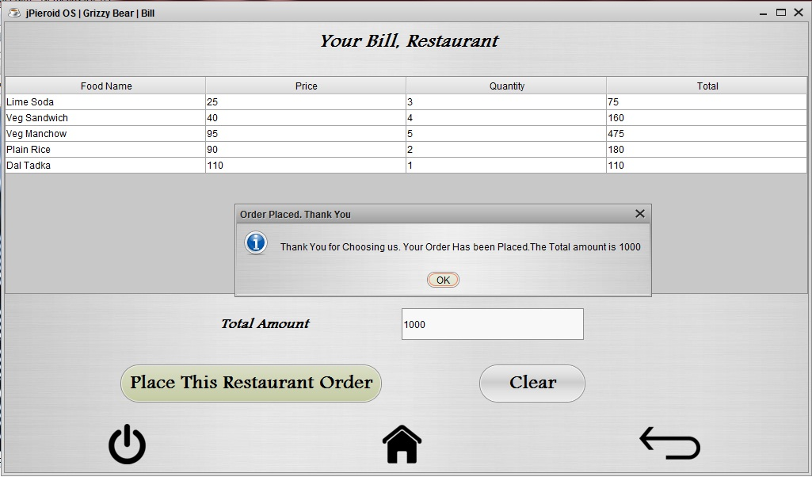

***PLACE*** ***THIS*** ***RESTAURANT*** ***ORDER***

private void jButton8ActionPerformed(java.awt.event.ActionEvent evt) {

int Tamt = Integer.parseInt(totalamtTF.getText());

JOptionPane.showMessageDialog(this, "Thank You for Choosing us. Your Order Has been Placed.The Total amount is " + Tamt + " ", "Order Placed. Thank You", JOptionPane.INFORMATION\_MESSAGE);

}

***CLEAR***

private void jButton23ActionPerformed(java.awt.event.ActionEvent evt) {

DefaultTableModel x=(DefaultTableModel) billTB.getModel();

int rows=x.getRowCount();

if(rows>0){

for(int i=0;i<rows;i++) {

x.removeRow(0);

}

}

totalamtTF.setText("");

}

**3.7 SETTINGS**

**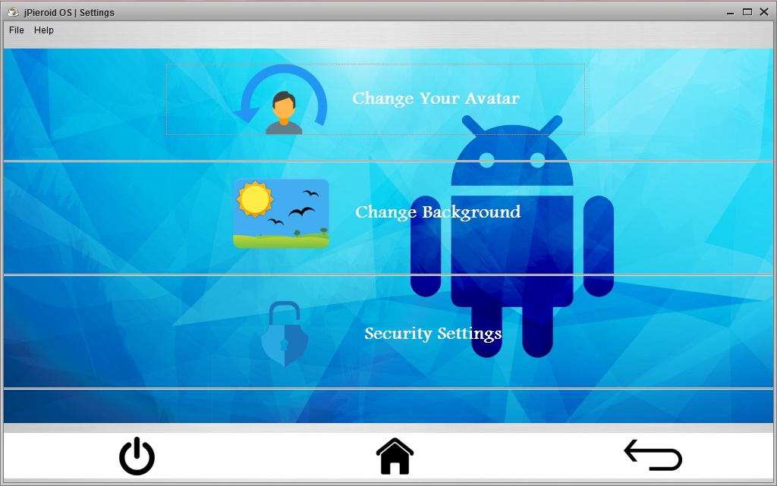**

***CHANGE*** ***YOUR*** ***AVATAR***

private void userbutActionPerformed(java.awt.event.ActionEvent evt) {

changeavatar.setVisible(true);

settings.dispose();

}

***CHANGE*** ***BACKGROUND***

private void displaybutActionPerformed(java.awt.event.ActionEvent evt) {

settings.dispose();

changeback.setVisible(true);

}

***SECURITY*** ***SETTINGS***

private void passchangebutActionPerformed(java.awt.event.ActionEvent evt) {

ssettings.setVisible(true);

settings.dispose();

}

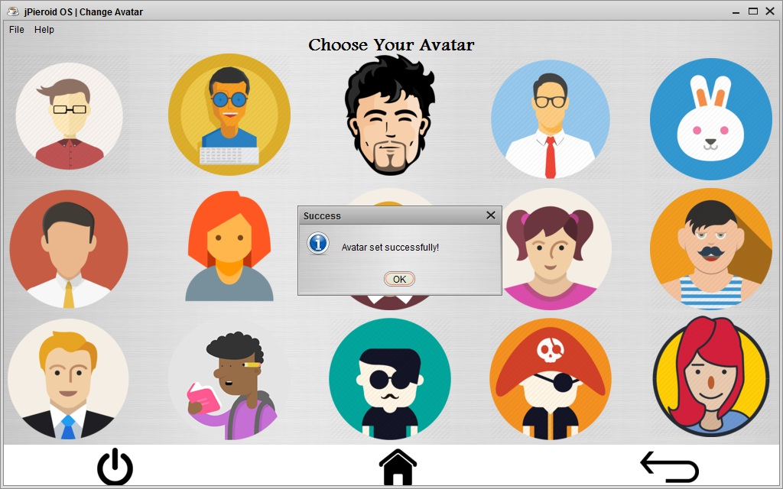

***CHANGE AVATAR***

***USER – 1***

private void userbut1ActionPerformed(java.awt.event.ActionEvent evt) {

try {

Class.forName("java.sql.Driver");

Connection con = DriverManager.getConnection("jdbc:mysql://localhost:3306/jos", "root", "bps");

Statement stmt = con.createStatement();

String query = "Update useravatar set avatar='user1.png'";

int n = stmt.executeUpdate(query);

userlabel.setIcon(new ImageIcon(getClass().getResource("user1.png")));

JOptionPane.showMessageDialog(this, "Avatar set successfully!", "Success", JOptionPane.INFORMATION\_MESSAGE);

} catch (Exception e) {

System.out.println("Error");

}

}

***USER – 2***

private void userbut15ActionPerformed(java.awt.event.ActionEvent evt) {

try {

Class.forName("java.sql.Driver");

Connection con = DriverManager.getConnection("jdbc:mysql://localhost:3306/jos", "root", "bps");

Statement stmt = con.createStatement();

String query = "Update useravatar set avatar='user15.png'";

int n = stmt.executeUpdate(query);

userlabel.setIcon(new ImageIcon(getClass().getResource("user15.png")));

JOptionPane.showMessageDialog(this, "Avatar set successfully!", "Success", JOptionPane.INFORMATION\_MESSAGE);

} catch (Exception e) {

System.out.println("Error");

}

}

***USER – 3***

private void userbut7ActionPerformed(java.awt.event.ActionEvent evt) {

try {

Class.forName("java.sql.Driver");

Connection con = DriverManager.getConnection("jdbc:mysql://localhost:3306/jos", "root", "bps");

Statement stmt = con.createStatement();

String query = "Update useravatar set avatar='user7.png'";

int n = stmt.executeUpdate(query);

userlabel.setIcon(new ImageIcon(getClass().getResource("user7.png")));

JOptionPane.showMessageDialog(this, "Avatar set successfully!", "Success", JOptionPane.INFORMATION\_MESSAGE);

} catch (Exception e) {

System.out.println("Error");

}

}

***USER – 4***

private void userbut6ActionPerformed(java.awt.event.ActionEvent evt) {

try {

Class.forName("java.sql.Driver");

Connection con = DriverManager.getConnection("jdbc:mysql://localhost:3306/jos", "root", "bps");

Statement stmt = con.createStatement();

String query = "Update useravatar set avatar='user6.png'";

int n = stmt.executeUpdate(query);

userlabel.setIcon(new ImageIcon(getClass().getResource("user6.png")));

JOptionPane.showMessageDialog(this, "Avatar set successfully!", "Success", JOptionPane.INFORMATION\_MESSAGE);

} catch (Exception e) {

System.out.println("Error");

}

}

***USER – 5***

private void userbut4ActionPerformed(java.awt.event.ActionEvent evt) {

try {

Class.forName("java.sql.Driver");

Connection con = DriverManager.getConnection("jdbc:mysql://localhost:3306/jos", "root", "bps");

Statement stmt = con.createStatement();

String query = "Update useravatar set avatar='user4.png'";

int n = stmt.executeUpdate(query);

userlabel.setIcon(new ImageIcon(getClass().getResource("user4.png")));

JOptionPane.showMessageDialog(this, "Avatar set successfully!", "Success", JOptionPane.INFORMATION\_MESSAGE);

} catch (Exception e) {

System.out.println("Error");

}

}

***USER – 6***

private void userbut5ActionPerformed(java.awt.event.ActionEvent evt) {

try {

Class.forName("java.sql.Driver");

Connection con = DriverManager.getConnection("jdbc:mysql://localhost:3306/jos", "root", "bps");

Statement stmt = con.createStatement();

String query = "Update useravatar set avatar='user5.png'";

int n = stmt.executeUpdate(query);

userlabel.setIcon(new ImageIcon(getClass().getResource("user5.png")));

JOptionPane.showMessageDialog(this, "Avatar set successfully!", "Success", JOptionPane.INFORMATION\_MESSAGE);

} catch (Exception e) {

System.out.println("Error");

}

}

***USER – 7***

private void userbut3ActionPerformed(java.awt.event.ActionEvent evt) {

try {

Class.forName("java.sql.Driver");

Connection con = DriverManager.getConnection("jdbc:mysql://localhost:3306/jos", "root", "bps");

Statement stmt = con.createStatement();

String query = "Update useravatar set avatar='user3.png'";

int n = stmt.executeUpdate(query);

userlabel.setIcon(new ImageIcon(getClass().getResource("user3.png")));

JOptionPane.showMessageDialog(this, "Avatar set successfully!", "Success", JOptionPane.INFORMATION\_MESSAGE);

} catch (Exception e) {

System.out.println("Error");

}

}

***USER – 8***

private void userbut8ActionPerformed(java.awt.event.ActionEvent evt) {

try {

Class.forName("java.sql.Driver");

Connection con = DriverManager.getConnection("jdbc:mysql://localhost:3306/jos", "root", "bps");

Statement stmt = con.createStatement();

String query = "Update useravatar set avatar='user8.png'";

int n = stmt.executeUpdate(query);

userlabel.setIcon(new ImageIcon(getClass().getResource("user8.png")));

JOptionPane.showMessageDialog(this, "Avatar set successfully!", "Success", JOptionPane.INFORMATION\_MESSAGE);

} catch (Exception e) {

System.out.println("Error");

}

}

***USER – 9***

private void userbut9ActionPerformed(java.awt.event.ActionEvent evt) {

try {

Class.forName("java.sql.Driver");

Connection con = DriverManager.getConnection("jdbc:mysql://localhost:3306/jos", "root", "bps");

Statement stmt = con.createStatement();

String query = "Update useravatar set avatar='user9.png'";

int n = stmt.executeUpdate(query);

userlabel.setIcon(new ImageIcon(getClass().getResource("user9.png")));

JOptionPane.showMessageDialog(this, "Avatar set successfully!", "Success", JOptionPane.INFORMATION\_MESSAGE);

} catch (Exception e) {

System.out.println("Error");

}

}

***USER – 10***

private void userbut10ActionPerformed(java.awt.event.ActionEvent evt) {

try {

Class.forName("java.sql.Driver");

Connection con = DriverManager.getConnection("jdbc:mysql://localhost:3306/jos", "root", "bps");

Statement stmt = con.createStatement();

String query = "Update useravatar set avatar='user10.png'";

int n = stmt.executeUpdate(query);

userlabel.setIcon(new ImageIcon(getClass().getResource("user10.png")));

JOptionPane.showMessageDialog(this, "Avatar set successfully!", "Success", JOptionPane.INFORMATION\_MESSAGE);

} catch (Exception e) {

System.out.println("Error");

}

}

***USER – 11***

private void userbut11ActionPerformed(java.awt.event.ActionEvent evt) {

try {

Class.forName("java.sql.Driver");

Connection con = DriverManager.getConnection("jdbc:mysql://localhost:3306/jos", "root", "bps");

Statement stmt = con.createStatement();

String query = "Update useravatar set avatar='user11.png'";

int n = stmt.executeUpdate(query);

userlabel.setIcon(new ImageIcon(getClass().getResource("user11.png")));

JOptionPane.showMessageDialog(this, "Avatar set successfully!", "Success", JOptionPane.INFORMATION\_MESSAGE);

} catch (Exception e) {

System.out.println("Error");

}

}

***USER – 12***

private void userbut12ActionPerformed(java.awt.event.ActionEvent evt) {

try {

Class.forName("java.sql.Driver");

Connection con = DriverManager.getConnection("jdbc:mysql://localhost:3306/jos", "root", "bps");

Statement stmt = con.createStatement();

String query = "Update useravatar set avatar='user12.png'";

int n = stmt.executeUpdate(query);

userlabel.setIcon(new ImageIcon(getClass().getResource("user12.png")));

JOptionPane.showMessageDialog(this, "Avatar set successfully!", "Success", JOptionPane.INFORMATION\_MESSAGE);

} catch (Exception e) {

System.out.println("Error");

}

}

***USER – 13***

private void userbut13ActionPerformed(java.awt.event.ActionEvent evt) {

try {

Class.forName("java.sql.Driver");

Connection con = DriverManager.getConnection("jdbc:mysql://localhost:3306/jos", "root", "bps");

Statement stmt = con.createStatement();

String query = "Update useravatar set avatar='user13.png'";

int n = stmt.executeUpdate(query);

userlabel.setIcon(new ImageIcon(getClass().getResource("user13.png")));

JOptionPane.showMessageDialog(this, "Avatar set successfully!", "Success", JOptionPane.INFORMATION\_MESSAGE);

} catch (Exception e) {

System.out.println("Error");

}

}

***USER – 14***

private void userbut14ActionPerformed(java.awt.event.ActionEvent evt) {

try {

Class.forName("java.sql.Driver");

Connection con = DriverManager.getConnection("jdbc:mysql://localhost:3306/jos", "root", "bps");

Statement stmt = con.createStatement();

String query = "Update useravatar set avatar='user14.png'";

int n = stmt.executeUpdate(query);

userlabel.setIcon(new ImageIcon(getClass().getResource("user14.png")));

JOptionPane.showMessageDialog(this, "Avatar set successfully!", "Success", JOptionPane.INFORMATION\_MESSAGE);

} catch (Exception e) {

System.out.println("Error");

}

}

***USER – 15***

private void userbut15ActionPerformed(java.awt.event.ActionEvent evt) {

try {

Class.forName("java.sql.Driver");

Connection con = DriverManager.getConnection("jdbc:mysql://localhost:3306/jos", "root", "bps");

Statement stmt = con.createStatement();

String query = "Update useravatar set avatar='user2.png'";

int n = stmt.executeUpdate(query);

userlabel.setIcon(new ImageIcon(getClass().getResource("user2.png")));

JOptionPane.showMessageDialog(this, "Avatar set successfully!", "Success", JOptionPane.INFORMATION\_MESSAGE);

} catch (Exception e) {

System.out.println("Error");

}

}

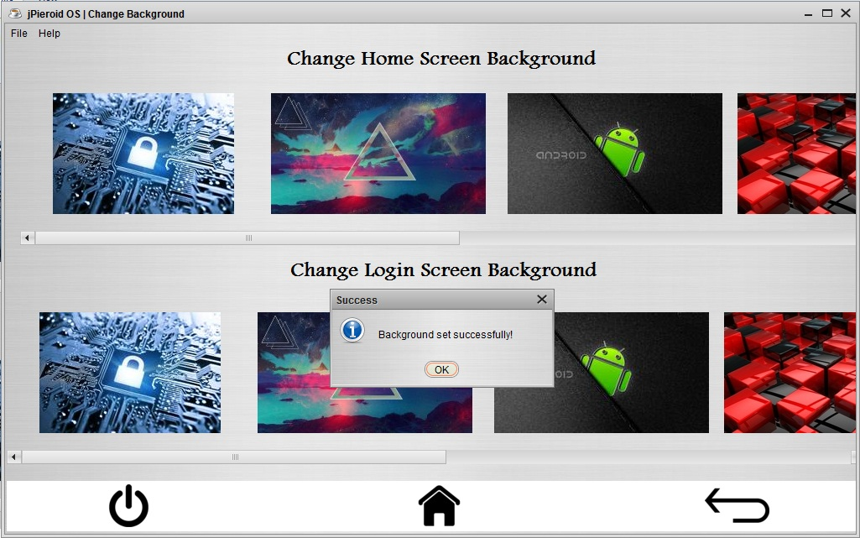

***CHANGE*** ***HOME*** ***SCREEN*** ***BACKGROUND***

***WAL – 1***

private void wallbut8ActionPerformed(java.awt.event.ActionEvent evt) {

try {

Class.forName("java.sql.Driver");

Connection con = DriverManager.getConnection("jdbc:mysql://localhost:3306/jos", "root", "bps");

Statement stmt = con.createStatement();

String query = "Update backgrounds set homescreen='back1.jpg'";

int n = stmt.executeUpdate(query);

homelabel.setIcon(new ImageIcon(getClass().getResource("back1.jpg")));

menulabel.setIcon(new ImageIcon(getClass().getResource("back1.jpg")));

JOptionPane.showMessageDialog(this, "Background set successfully!", "Success", JOptionPane.INFORMATION\_MESSAGE);

} catch (Exception e) {

System.out.println("Error");

}

}

***WAL – 2***

private void wallbut9ActionPerformed(java.awt.event.ActionEvent evt) {

try {

Class.forName("java.sql.Driver");

Connection con = DriverManager.getConnection("jdbc:mysql://localhost:3306/jos", "root", "bps");

Statement stmt = con.createStatement();

String query = "Update backgrounds set homescreen='back2.jpg'";

int n = stmt.executeUpdate(query);

homelabel.setIcon(new ImageIcon(getClass().getResource("back2.jpg")));

menulabel.setIcon(new ImageIcon(getClass().getResource("back2.jpg")));

JOptionPane.showMessageDialog(this, "Background set successfully!", "Success", JOptionPane.INFORMATION\_MESSAGE);

} catch (Exception e) {

System.out.println("Error");

}

}

***WAL – 3***

private void wallbut10ActionPerformed(java.awt.event.ActionEvent evt) {

try {

Class.forName("java.sql.Driver");

Connection con = DriverManager.getConnection("jdbc:mysql://localhost:3306/jos", "root", "bps");

Statement stmt = con.createStatement();

String query = "Update backgrounds set homescreen='back3.jpg'";

int n = stmt.executeUpdate(query);

homelabel.setIcon(new ImageIcon(getClass().getResource("back3.jpg")));

menulabel.setIcon(new ImageIcon(getClass().getResource("back3.jpg")));

JOptionPane.showMessageDialog(this, "Background set successfully!", "Success", JOptionPane.INFORMATION\_MESSAGE);

} catch (Exception e) {

System.out.println("Error");

}

}

***WAL – 4***

private void wallbut11ActionPerformed(java.awt.event.ActionEvent evt) {

try {

Class.forName("java.sql.Driver");

Connection con = DriverManager.getConnection("jdbc:mysql://localhost:3306/jos", "root", "bps");

Statement stmt = con.createStatement();

String query = "Update backgrounds set homescreen='back4.jpg'";

int n = stmt.executeUpdate(query);

homelabel.setIcon(new ImageIcon(getClass().getResource("back4.jpg")));

menulabel.setIcon(new ImageIcon(getClass().getResource("back4.jpg")));

JOptionPane.showMessageDialog(this, "Background set successfully!", "Success", JOptionPane.INFORMATION\_MESSAGE);

} catch (Exception e) {

System.out.println("Error");

}

}

***WAL – 5***

private void wallbut12ActionPerformed(java.awt.event.ActionEvent evt) {

try {

Class.forName("java.sql.Driver");

Connection con = DriverManager.getConnection("jdbc:mysql://localhost:3306/jos", "root", "bps");

Statement stmt = con.createStatement();

String query = "Update backgrounds set homescreen='back5.jpg'";

int n = stmt.executeUpdate(query);

homelabel.setIcon(new ImageIcon(getClass().getResource("back5.jpg")));

menulabel.setIcon(new ImageIcon(getClass().getResource("back5.jpg")));

JOptionPane.showMessageDialog(this, "Background set successfully!", "Success", JOptionPane.INFORMATION\_MESSAGE);

} catch (Exception e) {

System.out.println("Error");

}

}

***WAL – 6***

private void wallbut13ActionPerformed(java.awt.event.ActionEvent evt) {

try {

Class.forName("java.sql.Driver");

Connection con = DriverManager.getConnection("jdbc:mysql://localhost:3306/jos", "root", "bps");

Statement stmt = con.createStatement();

String query = "Update backgrounds set homescreen='back6.jpg'";

int n = stmt.executeUpdate(query);

homelabel.setIcon(new ImageIcon(getClass().getResource("back6.jpg")));

menulabel.setIcon(new ImageIcon(getClass().getResource("back6.jpg")));

JOptionPane.showMessageDialog(this, "Background set successfully!", "Success", JOptionPane.INFORMATION\_MESSAGE);

} catch (Exception e) {

System.out.println("Error");

}

}

***WAL – 7***

private void wallbut14ActionPerformed(java.awt.event.ActionEvent evt) {

try {

Class.forName("java.sql.Driver");

Connection con = DriverManager.getConnection("jdbc:mysql://localhost:3306/jos", "root", "bps");

Statement stmt = con.createStatement();

String query = "Update backgrounds set homescreen='back7.jpg'";

int n = stmt.executeUpdate(query);

homelabel.setIcon(new ImageIcon(getClass().getResource("back7.jpg")));

menulabel.setIcon(new ImageIcon(getClass().getResource("back7.jpg")));

JOptionPane.showMessageDialog(this, "Background set successfully!", "Success", JOptionPane.INFORMATION\_MESSAGE);

} catch (Exception e) {

System.out.println("Error");

}

}

***CHANGE*** ***LOGIN*** ***SCREEN*** ***BACKGROUND***

***WAL – 1***

private void wallbut1ActionPerformed(java.awt.event.ActionEvent evt) {

try {

Class.forName("java.sql.Driver");

Connection con = DriverManager.getConnection("jdbc:mysql://localhost:3306/jos", "root", "bps");

Statement stmt = con.createStatement();

String query = "Update backgrounds set loginscreen='back1.jpg'";

int n = stmt.executeUpdate(query);

loginlabel.setIcon(new ImageIcon(getClass().getResource("back1.jpg")));

JOptionPane.showMessageDialog(this, "Background set successfully!", "Success", JOptionPane.INFORMATION\_MESSAGE);

} catch (Exception e) {

System.out.println("Error");

}

}

***WAL – 2***

private void wallbut2ActionPerformed(java.awt.event.ActionEvent evt) {

try {

Class.forName("java.sql.Driver");

Connection con = DriverManager.getConnection("jdbc:mysql://localhost:3306/jos", "root", "bps");

Statement stmt = con.createStatement();

String query = "Update backgrounds set loginscreen='back2.jpg'";

int n = stmt.executeUpdate(query);

loginlabel.setIcon(new ImageIcon(getClass().getResource("back2.jpg")));

JOptionPane.showMessageDialog(this, "Background set successfully!", "Success", JOptionPane.INFORMATION\_MESSAGE);

} catch (Exception e) {

System.out.println("Error");

}

}

***WAL – 3***

private void wallbut3ActionPerformed(java.awt.event.ActionEvent evt) {

try {

Class.forName("java.sql.Driver");

Connection con = DriverManager.getConnection("jdbc:mysql://localhost:3306/jos", "root", "bps");

Statement stmt = con.createStatement();

String query = "Update backgrounds set loginscreen='back3.jpg'";

int n = stmt.executeUpdate(query);

loginlabel.setIcon(new ImageIcon(getClass().getResource("back3.jpg")));

JOptionPane.showMessageDialog(this, "Background set successfully!", "Success", JOptionPane.INFORMATION\_MESSAGE);

} catch (Exception e) {

System.out.println("Error");

}

}

***WAL – 4***

private void wallbut4ActionPerformed(java.awt.event.ActionEvent evt) {

try {

Class.forName("java.sql.Driver");

Connection con = DriverManager.getConnection("jdbc:mysql://localhost:3306/jos", "root", "bps");

Statement stmt = con.createStatement();

String query = "Update backgrounds set loginscreen='back4.jpg'";

int n = stmt.executeUpdate(query);

loginlabel.setIcon(new ImageIcon(getClass().getResource("back4.jpg")));

JOptionPane.showMessageDialog(this, "Background set successfully!", "Success", JOptionPane.INFORMATION\_MESSAGE);

} catch (Exception e) {

System.out.println("Error");

}

}

***WAL – 5***

private void wallbut5ActionPerformed(java.awt.event.ActionEvent evt) {

try {

Class.forName("java.sql.Driver");

Connection con = DriverManager.getConnection("jdbc:mysql://localhost:3306/jos", "root", "bps");

Statement stmt = con.createStatement();

String query = "Update backgrounds set loginscreen='back5.jpg'";

int n = stmt.executeUpdate(query);

loginlabel.setIcon(new ImageIcon(getClass().getResource("back5.jpg")));

JOptionPane.showMessageDialog(this, "Background set successfully!", "Success", JOptionPane.INFORMATION\_MESSAGE);

} catch (Exception e) {

System.out.println("Error");

}

}

***WAL – 6***

private void wallbut6ActionPerformed(java.awt.event.ActionEvent evt) {

try {

Class.forName("java.sql.Driver");

Connection con = DriverManager.getConnection("jdbc:mysql://localhost:3306/jos", "root", "bps");

Statement stmt = con.createStatement();

String query = "Update backgrounds set loginscreen='back6.jpg'";

int n = stmt.executeUpdate(query);

loginlabel.setIcon(new ImageIcon(getClass().getResource("back6.jpg")));

JOptionPane.showMessageDialog(this, "Background set successfully!", "Success", JOptionPane.INFORMATION\_MESSAGE);

} catch (Exception e) {

System.out.println("Error");

}

}

***WAL – 7***

private void wallbut7ActionPerformed(java.awt.event.ActionEvent evt) {

try {

Class.forName("java.sql.Driver");

Connection con = DriverManager.getConnection("jdbc:mysql://localhost:3306/jos", "root", "bps");

Statement stmt = con.createStatement();

String query = "Update backgrounds set loginscreen='back7.jpg'";

int n = stmt.executeUpdate(query);

loginlabel.setIcon(new ImageIcon(getClass().getResource("back7.jpg")));

JOptionPane.showMessageDialog(this, "Background set successfully!", "Success", JOptionPane.INFORMATION\_MESSAGE);

} catch (Exception e) {

System.out.println("Error");

}

}

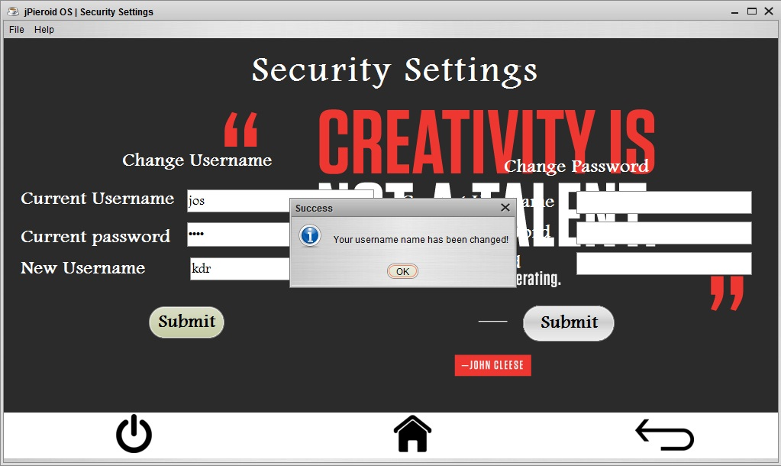

***SUBMIT*** ***USERNAME***

private void jButton1ActionPerformed(java.awt.event.ActionEvent evt) {

String username = curuserTF.getText();

String pass = new String(curpassTF.getPassword());

String newuser = newuserTF.getText();

if (username.equals(curusername) && pass.equals(curpassword)) {

try {

Class.forName("java.sql.Driver");

Connection con = DriverManager.getConnection("jdbc:mysql://localhost:3306/jos", "root", "bps");

Statement stmt = con.createStatement();

String query = "Update userpass set username='" + newuser + "'";

int n = stmt.executeUpdate(query);

JOptionPane.showMessageDialog(this, "Your username name has been changed!", "Success", JOptionPane.INFORMATION\_MESSAGE);

} catch (Exception e) {

System.out.println("Error");

}

curusername = newuser;

} else {

JOptionPane.showMessageDialog(null, "Your username or password is wrong");

}

curuserTF.setText("");

curpassTF.setText("");

curuser2TF.setText("");

curpass2TF.setText("");

newuserTF.setText("");

newpassTF.setText("");

}

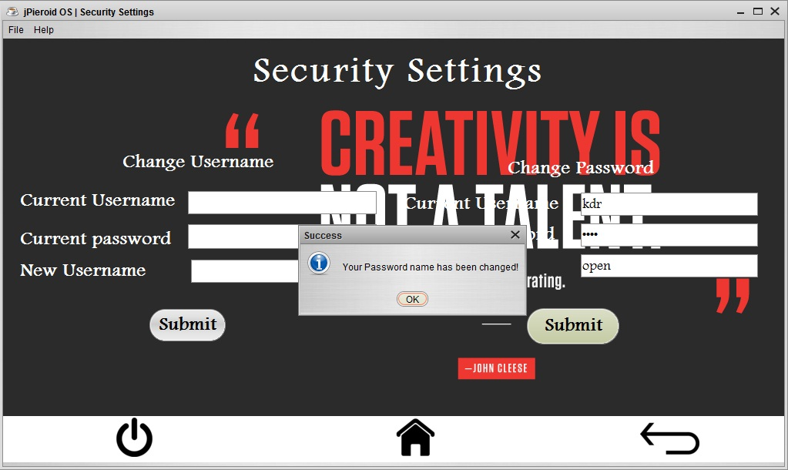

***SUBMIT PASSWORD***

private void jButton2ActionPerformed(java.awt.event.ActionEvent evt) {

String username = curuser2TF.getText();

String pass = new String(curpass2TF.getPassword());

String newpass = newpassTF.getText();

if (username.equals(curusername) && pass.equals(curpassword)) {

try {

Class.forName("java.sql.Driver");

Connection con = DriverManager.getConnection("jdbc:mysql://localhost:3306/jos", "root", "bps");

Statement stmt = con.createStatement();

String query = "Update userpass set password='" + newpass + "'";

int n = stmt.executeUpdate(query);

JOptionPane.showMessageDialog(this, "Your Password name has been changed!", "Success", JOptionPane.INFORMATION\_MESSAGE);

} catch (Exception e) {

System.out.println("Error");

}

curpassword = newpass;

} else {

JOptionPane.showMessageDialog(null, "Your username or password is wrong");

}

curuserTF.setText("");

curpassTF.setText("");

curuser2TF.setText("");

curpass2TF.setText("");

newuserTF.setText("");

newpassTF.setText("");

}

**6. uSEr manual**

## 6.1 How to install Software:

### Hardware Requirement-

* Intel Core™/Celeron or similar processor based PC at Client/Server end.
* 128 MB RAM and 4GB HDD space (for Database) is desirable.
* Standard I/O devices like Keyboard and Mouse etc.
* Printer is needed for hard-copy reports.
* Local Area Network(LAN) is required for Client-Server Installation

### Software Requirement-

* Windows 7 OS is desirable.
* NetBeans Ver 8.2 or higher should be installed with JDK and JVM.
* MySQL Ver 5.0 with jos Database must be present at machine.

### Database Installation

The software project is distributed with a backup copy of a Database named **jos** with required tables. Some dummy records are present in the tables for testing purposes, which can be deleted before inserting real data. The project is shipped with **jPieroid OS**.sql file which installs a database and tables in the computer system.

Note: The PC must have MySQL server with user (***root***) and password (***bps***) . If root password is any other password, it can be changed by running MySQL Server Instance Configure Wizard.

Start ⏵Program ⏵ MySQL ⏵MySQL Server ⏵MySQL Server Instance Config Wizard Provide current password of root and new password as “bps” , this will change the root password.

To install a MySQL database from a dump file ***(*jPieroid OS.sql*)*** , simply follow the following steps.

**Step 1:** Copy the **jPieroid OS**.sql file in **C:\Program files\Mysql\MySql server 5.0\Bin** folder.

**Step 2:** Open MySQL and type the following command to create the dabase named **jos**.

mysql> create database **jos**;

**Step 3:** Open Command Window (Start ⏵Run ⏵ cmd)

**Step 4:** Go to the following folder using CD command of DOS.

**C:\Program files\Mysql\MySql server 5.0\Bin>**

**Step 5:** type the following command on above prompt -

**C:….\bin>** mysql -u ***root*** -p***bps*** jos< jPieroid OS.sql

This will create a jos database with required tables.

**7. rEFErences**

In order to work on this project titled -***jPieroid OS,*** the following books and literature are referred by me during the various phases of development of the project.

(1) Informatics Practices for class XII

-by Sumita Arora

(2) <http://www.mysql.org/>

(3) <http://www.netbeans.org>/

(4) On-line Help of NetBeans ®

(5) Java IDE Book

- by Shildit

(6) Various Websites of Discussion Forum and software development activities.

Other than the above-mentioned books, the suggestions of my teacher and my class experience also helped me to develop this software project.